Following the Dean of Libraries Affairs Dr. Abdulaziz Ibrahim Alomran's instructions, Dr. Osamah Mohammad Atteyyah Khamees will be in charge of building, developing, enriching and managing the digital content of the electronic gate of deanship.

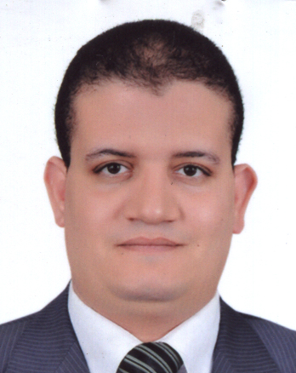

Dr. Usamah Mohammad Atteyyah Khamees
Assistan professor of libraries science and information technology
Head of Quality Center
Supervisor of Information Technology
Deanship of Libraries Affairs
Contact
E-mail: o.khames@mu.edu.sa
Personal website: http://faculty.mu.edu.sa/okhames

