Spring 2017

Department: | Information Technology
Course Code & Title: | IS 232: Database Management Systems
Name of the Faculty Member | Prof. Saravanan

Question | Outcome | Assessment Tool
- 2a. Consider the following diagram. What inference can you make in the diagram? What is the role of user in it?  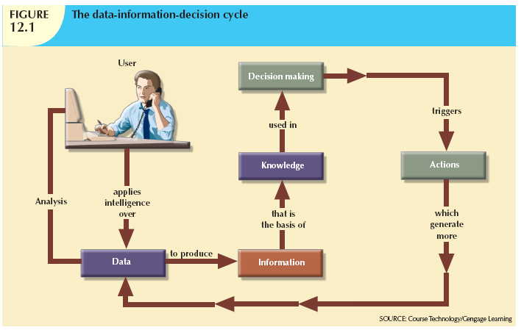 | b | Mid Exam
- 2b. What is the function of the Database Administrator(DBA) in the following diagram. Categorise the functions and explain.  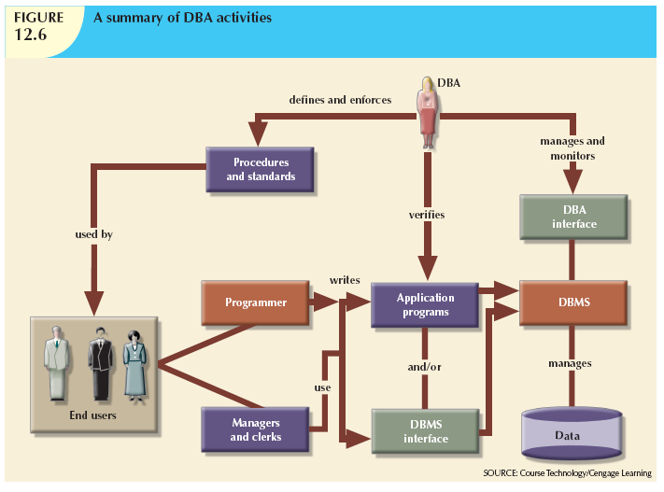 | b | Mid Exam
- 2c.Transactions are very important and is the base for concurrency control. Can you explain which three properties are widely used and very important for concurrency control? | b | Mid Exam
- 2e.The following table demonstrate the impact of using rollback in two concurrent transactions. Troubleshoot the errors in the following diagram.  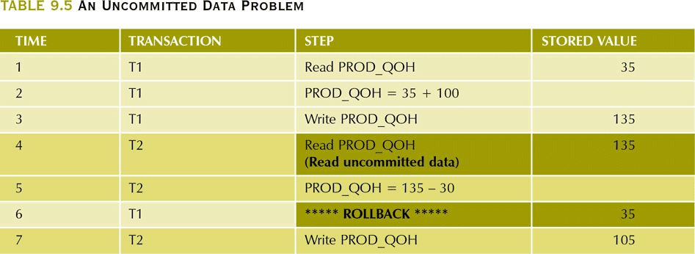 | b | Mid Exam
4a.Analyse the need of the transaction management. Identify the important properties of a transaction | b | Final Exam
4b.Critically analyse the following diagram. Identify the type of lock and its advantages.  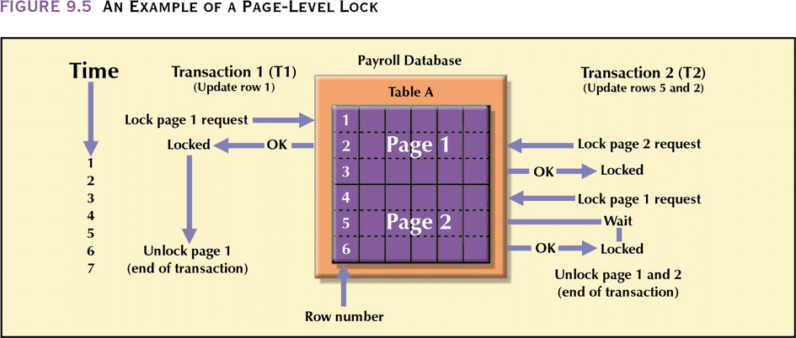 | b | Final Exam
5a.Compare the table level lock and database level lock. Identify the importance of both the locks. | b | Final Exam
5b. What do you understand from the following diagram related to deadlocks. Identify the procedures available to control the deadlocks.  - 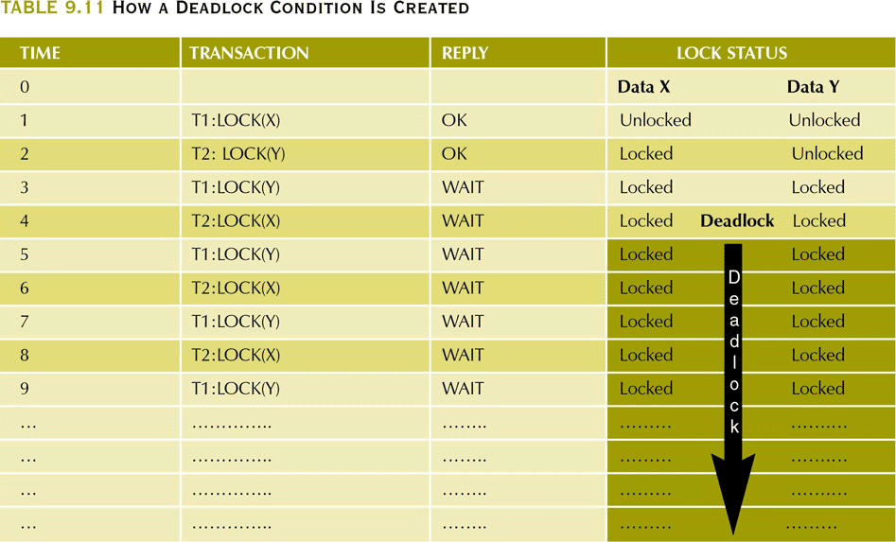 | b | Final Exam
Suppose that you are a manufacturer of product ABC, which is composed of parts A, B, C. Each time a new product ABC is created, it must be added to the product inventory, using the PROD_QOH in PRODUCT table. And each time the product is created the parts inventory, using PART_QOH in PART table must be reduced by one each of parts, A, B, and C.  PRODUCT  PROD_CODE PROD_QOH  ABC 1205  PART  PART_CODE PART_QOH  A 567  B 98  C 549  - How many database requests can you identify for an inventory update for both PRODUCT and PART?  - Using SQL, write each database request you have identified above.  - Write the complete transactions using SQL.  - Write the transaction log file contents for the queries provided in question number 3. | d | Homework 1/Assignment 1
This assignment covers the following:  - Configuring your database for backups (4 Marks)  - Backing up your database while the database is open for user activity (3 Marks)  - Scheduling automatic nightly incremental backups for your database (3 Marks)  Explain the above three questions with the detailed steps and screenshots. | d | Homework 2/Assignment 2
As a DBA, perform the following operations for effective data management  - Monitoring the Oracle Instance  - Introduction and using Oracle Data Dictionary  - Creating a Database  - Tablespace and data file Management  - Display and Analyze redo log details  - Display and Analyze control files  - Display and Analyze Archive log details  - Create User Profiles and Users,  - Manage Roles and Privileges  - Backup and Recovery | i | Exercise
6a. You are a database administrator of an organization. Analyse the following database architecture diagram(Oracle 11g and 12c) and identify the responsibilities of each parts listed in the diagram.  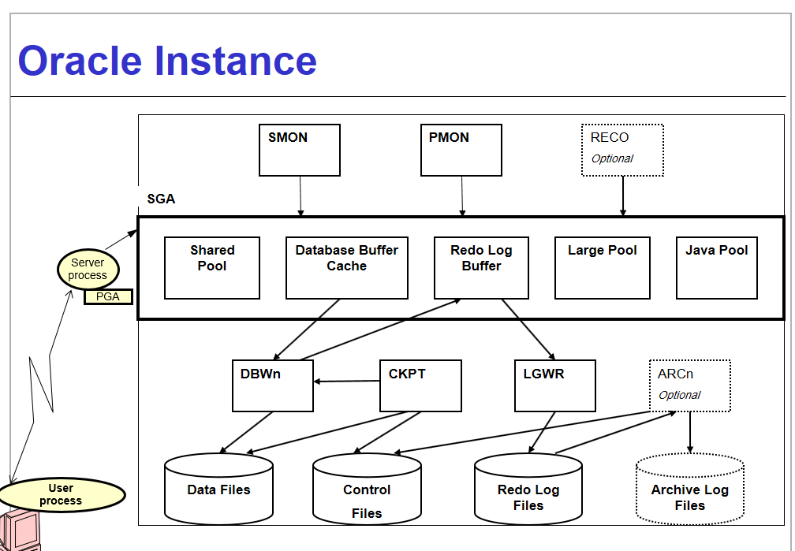 | i | Final Exam

The final judgment of the attainment of student outcomes is based on the following:

Exceeds  Expectations  (EE) | Meets  Expectations  (ME) | Progressing  Towards Expectations  (PE) | Does Not Meet  Expectations  (DNME)
80% or more of  students are  achieving the  satisfactory level  or above | 70% - 80%  of students are achieving the satisfactory level or above | 60% - 70%  of students are achieving  the satisfactory level  or above | Below 60%  of students are  achieving the  satisfactory level  or above

When analyzing the results of the assessment of a course, we must necessarily pay attention to the following cases:
- Cases where we have DNME in a specific outcome.
- Cases where we have PE in a specific outcome.
- Cases where we have an important discrepancy (let's say > 15%) between direct and indirect assessment for a specific outcome; especially if the direct assessment (opinion of teacher) is much higher than the indirect assessment (opinion of students).
- Online Student Survey: if we have questions with DNME or PE, we should also comment them.
The analysis of the assessment results must be oriented towards:
- Identifying the reasons, issues, and root causes behind the non-attainment of a specific outcome.
Outcome | Course | Instrument | Attainment Level
B | Database Management Systems | Midterm | ME
 |  | Homework | PE
D |  | Exercise | ME
I |  | Final Exam | EE
- Determining corrective actions to be taken in the following semester to resolve those issues.

Result of the Assessment:

The attainment level for homework is PE, due to the reason that, many students were absent during the first 2/3 weeks. The basics were covered during that week. In order to reach higher level of outcome, the week students were identified and provided extra training during Week 9/10. Hence, the attainment level is ME in Exercise.

