Mechanical and Industrial Engineering Department | Experimental

Refrigeration and Air- Conditioning (ME 355)
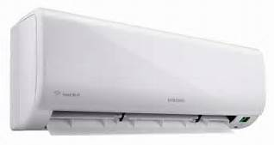
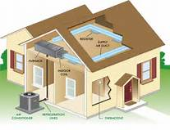
Experiments Manual

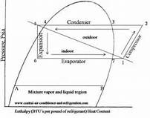
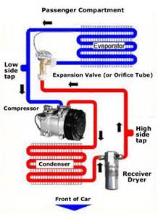

Updated 2017

Table of Contents
No | Experiment | Page
1 | To study the cycle of Air Conditioner system and measure related temperatures and pressure of Air Conditioner system. | 3
2 | To study and draw the vapor compression cycle between -5 ⁰C and 40 ⁰C on p-h diagram of R-12 refrigerant. | 7
3. | Representation of the indicated refrigeration cycle of the trainer for the refrigerant R-410a, and find C.O.P of the cycle. | 11
4. | To study the vapor absorption system. | 16
5. | To study and draw the vapor compression cycle between -5 ⁰C and 30 ⁰C on p-h diagram of R-12 refrigerant. | 20

Mechanical and Industrial Engineering Department

Experiment (1) | To Measure the Temperature and Pressure on Air conditioning system

Student Name : | ID: | Section No.:
Supervisor: Dr. Vakkar Ali | Submission Date: | SLO:
Academic Year: 2017-2018 | Semester: First

Objective: To understand the working of Air-conditioning system.
APPARATUS AND DESCRIPTION: The following apparatus is required to explain the basics of Air-conditioning.
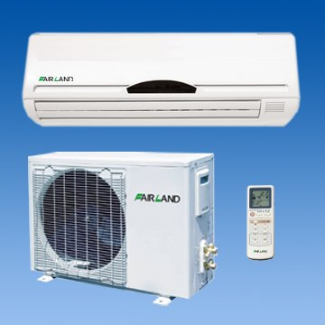

THEORY: The following formulae are used to find out the required quantities as below:
Refrigerating effect Re = h1 – h ₄
Work of compression W = h₂ –h₁
Coefficient of performance C.O.P = h₁ –h₄/h₂ –h₁
Heat rejected in condenser Qg = h₂ – h₃

EXPERIMENT PROCEDURE: The following steps are taken to draw the indicated refrigeration cycle on P-H diagram.
a. Draw the straight line at P_{e} = constant ie evaporator pressure
b. Draw a line along constant entropy line.
c. Draw a line along constant pressure P_{c} ie condenser pressure line. The condenser pressure line cuts the constant entropy line. The intersection is the exit of the compressor.
d. Finally draw constant enthalpy liny line from the saturation curve vertically and cuts the evaporator pressure line. The intersection of these two line is the entry of evaporator.

MESUREMENTS AND RESULTS: The results are shown in the following table after taking measurements.
S.N | Name of quantity | Value of the quantity
1. | Condenser pressure Pc | 21 bar, 22 bar absolute
2. | Evaporator pressure Pe | 8 Bar, 9 bar absolute
3. | Refrigerating effect Re | h₁ – h ₄
4. | Work of compression | h₂ –h₁
5. | Heat rejected in the condenser | h₂ –h₃
6. | Temperature at the end of compression | ----
7. | Coefficient of performance

DISCUSSION: The following points may be discussed for the given vapor compression cycle.
a. Effect of compressor evaporator pressure on C.O.P of the cycle.

b. Effect of pressure of condensing pressure on refrigerating effect.

c. Effect of sub cooling on refrigerating effect.

d. Effect of superheating of vapor in evaporator on refrigeration effect.

e. Effect of temperature at end of compression on work of compressor.

PRECAUTIONS: The following safety precaution should be taken while drawing the indicated vapor compression cycle.
- The values of high and low pressures depend strictly on the ambient temperature at which the air conditioner is installed.
- The values of different quantities plotting on the diagram carefully otherwise result would be wrong.
- The temperature of ambient should be measure carefully because all the parameters are depend on ambient temperature.

Mechanical and Industrial Engineering Department

Experiment (2) | To draw the vapour compression cycle on p-h diagram

Student Name : | ID: | Section No.:
Supervisor: Dr. Vakkar Ali | Submission Date: | SLO:
Academic Year: 2017-2018 | Semester: First

OBJECTIVE: To draw and understand the procedure of drawing vapor compression cycle on P-H diagram of R-12 and read the value of enthalpy at different point on P-H diagram.

APPARATUS AND DESCRIPTION: The following apparatus is required to take the reading of the required value of the temperature and pressure of the evaporator and compressor.
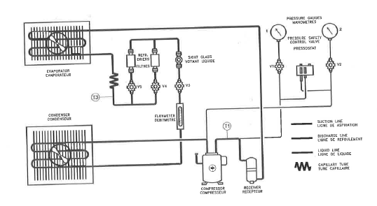

THEORY: The following formulae are used to find out the required quantities as below:
- Refrigerating effect Re = h₁ – h ₄
- Work of compression W = h₂ –h₁
- Coefficient of performance C.O.P = h₁ –h₂/h₂ –h₁
- Heat rejected in condenser Q_{g} = h₂ – h₃
- Temperature at end of compression T₂ =T₁ (P₂/P₁) ^{(k-1)/k}

EXPERIMENT PROCEDURE: The following steps are taken to draw the indicated refrigeration cycle on P-H diagram of R-12.
- Draw the straight line along -5⁰C on the p-h chart of R-12 .
- Draw the straight line along 40⁰C.
- Draw the constant entropy line from the end of evaporation till to the end of compression.
- Draw a vertical line from the saturation curve along constant enthalpy line.

MESUREMENTS AND RESULTS: The results are shown in the following table after taking measurements.
S.N | Name of quantity | Value of the quantity
1. | High pressure Pa
2. | Low pressure Pb
3. | Refrigerating effect Re
4. | Work of compression
5. | Heat rejected in the condenser
6. | Temperature at the end of compression
7. | Coefficient of performance

DISCUSSION: The following points may be discussed for the given vapor compression cycle.
- Effect of compressor evaporator pressure on C.O.P of the cycle.
- Effect of pressure of condensing pressure on refrigerating effect.
- Effect of sub cooling on refrigerating effect.
- Effect of superheating of vapor in evaporator on refrigeration effect.
- Effect of temperature at end of compression on work of compressor.

PRECAUTIONS: The following safety precaution should be taken while drawing the indicated vapor compression cycle.
- The values of high and low pressures depend strictly on the ambient temperature at which the air conditioner is installed.
- The values of different quantities plotting on the diagram carefully otherwise result would be wrong.
- The temperature of ambient should be measure carefully because all the parameters are depend on ambient temperature

Mechanical and Industrial Engineering Department

Experiment (3) | Representation of refrigeration cycle on 410 a p-h chart

Student Name : | ID: | Section No.:
Supervisor: Dr. Vakkar Ali | Submission Date: | SLO:
Academic Year: 2017-2018 | Semester: First

OBJECTIVE: To draw and understand the procedure of drawing vapor compression cycle on P-H diagram and read the value of enthalpy at different point on P-H diagram.
APPARATUS AND DESCRIPTION: The following apparatus is required to take the reading of the required value of the temperature and pressure of the evaporator and compressor.

THEORY: The following formulae are used to find out the required quantities as below:
- Refrigerating effect R_{e} = h₁ – h ₄
- Work of compression W = h₂ –h₁
- Coefficient of performance C.O.P = h₁ –h₂/h₂ –h₁
- Heat rejected in condenser Q_{g} = h₂ – h₃
- Temperature at end of compression T₂ =T₁ (P₂/P₁) ^{(k-1)/k}

EXPERIMENT PROCEDURE: The following steps are taken to draw the indicated refrigeration cycle on P-H diagram.
- Draw the straight line P_{a} = constant = 22 abs. bar, and P_{b} = constant = 9 abs .bar. Then draw a vertical line from the point 3 of the straight line Pa = 22 abs. bar and T₃ = 31.6 ⁰C until it intersect the line P_{b} = 9 abs. in the point 4.

- The segment 3-4 represents the work done by capillary tube, at constant enthalpy, to reduce the pressure of the liquid from 22 to 9 bars.

- Draw the parallel line to the adiabatic lines from the point 1 being on the intersection of the straight line P = 9 abs. bar and T₁ = 8 ⁰C until it intersects the other straight line P= constant= 22 abs. bar in the point 2.

- The segment 1-2 read on the enthalpy scale represents the work carried out by the compressor to increase the pressure of the vaporized refrigerant from P_{b} to P_{a.}

- The segment 2-3 read on the enthalpy scale represents the heat quantity that the superheated gas must lose to recover its liquid state.

- The temperature at the point 2 is higher than the value Tm measured by the thermometer: this is due to heat exchange occurring in the compressor between the gas in the delivery phase and the gas in the suction phase. This exchange is favored by the manufacturer of compressors.

- The temperature of the superheated gas can be found not only on the diagram. But also through the formula.

- The segment 4-5 read on the enthalpy scale represents the heat by the liquid from the external environment to become vapor.

MESUREMENTS AND RESULTS: The results are shown in the following table after taking measurements.
S.N | Name of quantity | Value of the quantity
1. | High pressure Pa | 21 bar, 22 bar absolute
2. | Low pressure Pb | 8 Bar, 9 bar absolute
3. | Refrigerating effect Re | -----
4. | Work of compression | ------
5. | Heat rejected in the condenser | ------
6. | Temperature at the end of compression | ----
7. | Coefficient of performance | -----

The results are shown on the following P-H chart as below:
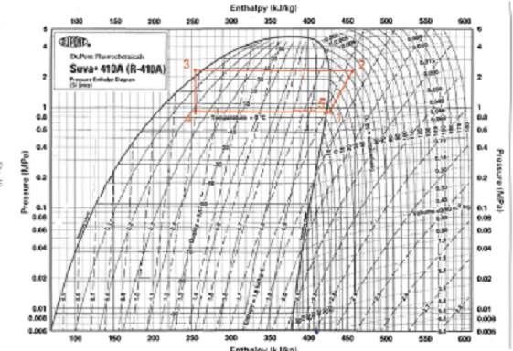

P-H Chart for R-410a

DISCUSSION: The following points may be discussed for the given vapor compression cycle.
- Effect of compressor evaporator pressure on C.O.P of the cycle.

- Effect of pressure of condensing pressure on refrigerating effect.

- Effect of sub cooling on refrigerating effect.

- Effect of superheating of vapor in evaporator on refrigeration effect.

- Effect of temperature at end of compression on work of compressor.

PRECAUTIONS: The following safety precaution should be taken while drawing the indicated vapor compression cycle.
- The values of high and low pressures depend strictly on the ambient temperature at which the air conditioner is installed.
- The values of different quantities plotting on the diagram carefully otherwise result would be wrong.
- The temperature of ambient should be measure carefully because all the parameters are depend on ambient temperature

Mechanical and Industrial Engineering Department

Experiment (4) | To study vapour absorption system

Student Name : | ID: | Section No.:
Supervisor: Dr. Vakkar Ali | Submission Date: | SLO:
Academic Year: 2017-2018 | Semester: First

EXPERIMENT-4
OBJECTIVE: To study the vapour absorption (domestic electrolux refrigerator) system.
THEORY: The vapour absorption refrigeration system is one of the oldest method of producing refrigerating effect. The principle of vapour absorption was first discovered by Michael Faraday in 1824 while performing a set of experiments to liquefy certain gases. A french scientist Ferdinand carre developed the first vapour absorption refrigeration machine in 1860. This system may be used in both the domestic and large industrial refrigerating plants. The refrigerant, commonly used in a vapour absorption system, is ammonia. The vapour absorption system uses heat energy, instead of mechanical energy as in vapour compression systems, in order to change the conditions of the refrigerant required for the operation of the refrigeration cycle.
In the vapour absorption system, an absorber, a pump, a generator and a pressure-reducing valve replace the compressor. These components in vapour absorption system perform the same function as that of a compressor in vapour compression system. In this system, the vapour refrigerant from the evaporator is drawn into an absorber where it is absorbed by the week solution of the refrigerant forming a strong solution. This strong solution is pumped to the generator where it is heated by some external source. During the heating process, the vapour refrigerant is driven off by the solution and enters into the condenser where it is liquefied. The liquid refrigerant then flows into the evaporator and thus the cycle is completed.
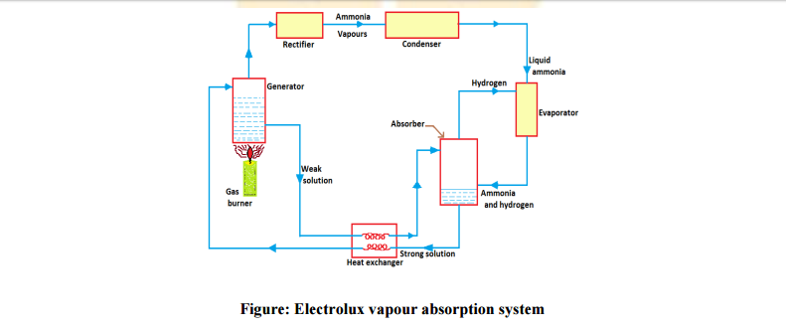

WORKING: The domestic absorption type refrigerator was invented by two Swedish engineers Carl Munters and Baltzer Van Platan in 1925 while they were studying for their under-graduate course of royal institute of technology in Stockholm. The idea was first developed by the ‘Electrolux Company’ of Luton, England. This type of refrigerator is also called three- fluids absorption system. The main purpose of this system is to eliminate the pump so that in the absence of moving parts, the machine becomes noise-less. The three fluids used in this system are ammonia, hydrogen and water.
The ammonia is used as a refrigerant because it possesses most of the desirable properties. It is toxic, but due to absence of moving parts, there are very little changes for the leakage and the total amount of refrigeration used is small. The hydrogen being the lightest gas is used to increase the rate of evaporation of the liquid ammonia passing through the evaporator. The hydrogen is also non-corrosive and insoluble in water. This is used in the low-pressure side of the system. The water is used as a solvent because it has the ability to absorb ammonia readily.
The strong ammonia solution from the absorber through heat exchanger is heated in the generator by applying heat from an external source usually a gas burner. During this heating process, ammonia vapour are removed from the solution and passed to the condenser. A rectifier or a water separator fitted before the condenser removes water vapour carried with the ammonia vapour, so that dry ammonia vapour are supplied to The condenser. These water vapour, if not removed, they will enter into the evaporator causing freezing and choking of the machine. The hot weak solution while passing through the exchanger is cooled. The heat removed by the weak solution is utilized in raising the temperature of strong solution passing through the heat exchanger. In this way, the absorption is accelerated and the improvement in the performance of a plant is achieved. The ammonia vapour in the condenser is condensed by using external cooling source. The liquid refrigerant leaving the condenser flows under gravity to the evaporator where it meets the hydrogen gas. The hydrogen gas which is being fed to the evaporator permits the liquid ammonia to evaporate at a low pressure and temperature according to Dalton’s principal. During the process of evaporation, the ammonia absorbs latent heat from the refrigerated space and thus produces cooling effect. The mixture of ammonia vapour and hydrogen is passed to the absorber where ammonia is absorbed in water while the hydrogen rises to the top and flows back to the evaporator.
The main disadvantage of electrolux refrigerator is: It can not be used for industrial purpose as the COP of the system is very low.
RESULT: Vapour refrigeration refrigeration system.

Mechanical and Industrial Engineering Department

Experiment (5) | To study and draw the refrigeration cycle on R-12 diagram

Student Name : | ID: | Section No.:
Supervisor: Dr. Vakkar Ali | Submission Date: | SLO:
Academic Year: 2017-2018 | Semester: First

OBJECTIVE: To draw and understand the procedure of drawing vapor compression cycle on P-H diagram of R-12 and read the value of enthalpy at different point on P-H diagram.
APPARATUS AND DESCRIPTION: The following apparatus is required to take the reading of the required value of the temperature and pressure of the evaporator and compressor.

Diagram of the Trainer-2
THEORY: The following formulae are used to find out the required quantities as below:
- Refrigerating effect Re = h₁ – h ₄
- Work of compression W = h₂ –h₁
- Coefficient of performance C.O.P = h₁ –h₂/h₂ –h₁
- Heat rejected in condenser Q_{g} = h₂ – h₃
- Temperature at end of compression T₂ =T₁ (P₂/P₁) ^{(k-1)/k}

EXPERIMENT PROCEDURE: The following steps are taken to draw the indicated refrigeration cycle on P-H diagram of R-12.
- Draw the straight line along -5⁰C on the p-h chart of R-12 .
- Draw the straight line along 30⁰C.
- Draw the constant entropy line from the end of evaporation till to the end of compression.
- Draw a vertical line from the saturation curve along constant enthalpy line.

MESUREMENTS AND RESULTS: The results are shown in the following table after taking measurements.
S.N | Name of quantity | Value of the quantity
1. | High pressure Pa
2. | Low pressure Pb
3. | Refrigerating effect Re
4. | Work of compression
5. | Heat rejected in the condenser
6. | Temperature at the end of compression
7. | Coefficient of performance

DISCUSSION: The following points may be discussed for the given vapor compression cycle.
- Effect of compressor evaporator pressure on C.O.P of the cycle.
- Effect of pressure of condensing pressure on refrigerating effect.
- Effect of sub cooling on refrigerating effect.
- Effect of superheating of vapor in evaporator on refrigeration effect.
- Effect of temperature at end of compression on work of compressor.

PRECAUTIONS: The following safety precaution should be taken while drawing the indicated vapor compression cycle.
- The values of high and low pressures depend strictly on the ambient temperature at which the air conditioner is installed.
- The values of different quantities plotting on the diagram carefully otherwise result would be wrong.
- The temperature of ambient should be measure carefully because all the parameters are depending on ambient temperature.

