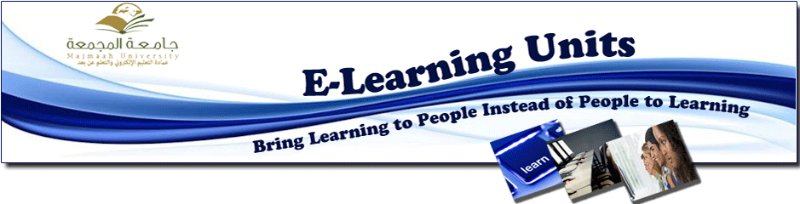

Technical Support concludes an exclusive training course in e-learning system
An exclusive training course for technical support staff of e-learning management system, commenced on Saturday 23rd Feb 2013, in the National Centre for Distance Learning and e-Learning, for three days in Riyadh.
trainees attended the course in order to benefit from the planned training outcomes in technical support.
Dr. Musallam al-Dosarie, the dean of e-learning, summarised the courses by saying “This course is highly important as it is aimed at enhancing instant effective technical support skills, that includes, the rollout of updates, provide end-user training when required, maintain maximum uptime and dealing with any issues that causes problems for the continuation of utilizing the system by end users”.
Technical support is available via:
- E-mail: End-uses send support request by email to elearning@mu.edu.sa
- Phone: End-users may request support by calling 064046666 (off campus) and 6666 (on campus)
You may contact technical support for:
- Registering a new technical problem or seek help in resolving a pending problem.
- Follow up on a pending problem.
- Reporting priority level of the problem.
- Requesting the status of the problem

