The Department of Research Chair Settle the Financial Matters of Research Chairs up to 31/8/2014

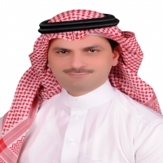
In compliance with the directives of His Excellency the Vice-Rector for Postgraduate Studies and Academic Research, Prof. Mohammad Bin Abdullah Al-Shaya’a, the department of research chair has settled all the financial issues up to the date 31/8/2014. The second meeting was also held by the committee assigned for the research chair department for the academic year 1435/1436. Dr. Abdullah Awwad Al-Harbi stated the supervising committee recommendations were reviewed during the first meeting which was chaired by Prof. Mohammad Al-Shaya’a, vice-rector for postgraduate studies and academic research and were approved to settle all the financial matters related to the activities and achievments of Sheikh Abdullah Bin Abdelmohsen Al-Tweijri Research Chair for Applied Research of Stroke in accordance with the estimated operational plan 2014 and the minutes of the scientific committee of the chair. The committee reviewed the reports pertinent to the scientific day held by King Khalid Hospital in Majmaah approved by the Saudi Commission for Stroke, the documents of submitting the patent to King Abdul Aziz city and the six books authored in the field of the chair. At the end of the meeting, the cheques of the abovementioned activities were issued which reached (190000 S.R.). Cheques of attending meetings and the supervisors were also issued. His Excellency the Rector, Dr. Khalid S. Al-Mugren stated the number of chairs is not that important. However; it is the quality of the chair what we are in pursuit of and the extent to which it serve the society.

