ATTACHMENT 2 (g)

Course Report

Kingdom of Saudi Arabia

The National Commission for Academic Accreditation & Assessment

COURSE REPORT
(CR)

A separate Course Report (CR) should be submitted for every course and for each section or campus location where the course is taught, even if the course is taught by the same person. Each CR is to be completed by the course instructor at the end of each course and given to the program coordinator

A combined, comprehensive CR should be prepared by the course coordinator and the separate location reports are to be attached.

Course Report

For guidance on the completion of this template refer to the NCAAA handbooks or the NCAAA Accreditation System help buttons.

Institution Faculty of Science Date of Course Report
College/ Department Mathematics Department

- Course Identification and General Information

1. Course title : Introduction To Topology Code MATH 472 Section: 444

2. Name of course instructor Abd El-Nasser Ghareeb Abd El-Rahman Location
3. Year and semester to which this report applies.1435
4. Number of students starting the course? 31 Students completing the course? 30
5. Course components (actual total contact hours and credits per semester):

Credit | Contact Hours |  |  |  | Self-Study | Other | Total
Credit | Lecture | Tutorial | Laboratory | Practical | Self-Study | Other | Total
4 | 45 | 15 |  |  | 75 | 18 | 153 ch

- - Course Delivery
1. Coverage of Planned Program
Topics Covered | Planned Contact Hours | Actual Contact Hours | Reason for Variations if there is a difference of more than 25% of the hours planned
Topological Spaces and examples. | 8 | 8
Closure of a set and derived set.  Topological subspaces. | 8 | 8
Bases, finite product topology and subbases. | 16 | 16
Metric spaces, examples and metrizability. | 8 | 8
Continuous functions and characterization of continuous functions and homeomorphisms.  Topological property. | 12 | 12
Compact spaces.  Limit point and sequentially compact spaces. | 8 | 8

2. Consequences of Non Coverage of Topics
For any topics where the topic was not taught or practically delivered, comment on how significant you believe the lack of coverage is for the course learning outcomes or for later courses in the program. Suggest possible compensating action.
Topics (if any) not Fully Covered | Effected Learning Outcomes | Possible Compensating Action
None

3. Course learning outcome assessment.

 | List course learning outcomes | List methods of assessment | Summary analysis of assessment results
1 | Define Topological Spaces and examples, closure of set and derived set, Topological subspaces, Bases, finite product topology and subbases, Metric spaces, examples and metrizability, Continuous functions and characterization of continuous functions and homeomorphisms, Topological property, Compact spaces, Limit point and sequentially compact spaces | Exams  Midterms  Final examination | Excellent
2 | Outline the logical thinking. | Home work. | good
3 | State the physical problems by mathematical method. | Continuous discussions with the students during the lectures. | good
4 | The students will explain and interpret a general knowledge of important mathematical concepts. | Midterm exams  Quizzes. | very good
5 | Enable students to analyses the mathematical problems. | Doing homework.  Check the problems solution. | above average
6 | Student's ability to write physical equations in a correct mathematical way. | Discussion of how to simplify or analyses some problems. | good
7 | The student should illustrate how take up responsibility. | Quizzes of some previous lectures.  Ask the absent students about last lecture. | weak
8 | Must be shown the ability of working independently and with groups. | Discussion during the lecture. | average
9 | The student should illustrate how to communicating with: Peers, Lecturers and Community. | Discussing a group work sheets. | above average
10 | The student should interpret how to Know the basic mathematical principles using the internet. | Discuses with them the results of computations analysis and problem solutions. | good
11 | The student should appraise how to Use the computer skills and library | Give homework's to know how the student understands the numerical skills. | average
12 | The student should illustrate how to Search the internet and using software programs to deal with problems. | Give them comments on some resulting numbers.

Summarize any actions you recommend for improving teaching strategies as a result of evaluations in table 3 above.

4. Effectiveness of Planned Teaching Strategies for Intended Learning Outcomes set out in the Course Specification. (Refer to planned teaching strategies in Course Specification and description of Domains of Learning Outcomes in the National Qualifications Framework)

List Teaching Methods set out in Course Specification | Were these  Effective? |  | Difficulties Experienced (if any) in Using the Strategy and Suggested Action to Deal with Those Difficulties.
List Teaching Methods set out in Course Specification | No | Yes
Start each chapter by general idea and the benefit of it.  Demonstrate the course information and principles through lectures. |  | √
Provide main ways to deal with the exercises. |  | √
Solve some examples during the lecture. |  | √
Encourage the student to look for some complicated problems in the different references. |  | √
Ask the student to attend lectures for practice solving problem.
Homework assignments. |  | √
Ask the students to search the internet and use the library.  Encourage them how to attend lectures regularly by assigning marks for attendance. |  | √
Teach them how to cover missed lectures.  Give students tasks of duties |  | √
Creating working groups with peers to collectively prepare: solving problems and search the internet for some topics. | √
Give the students tasks to measure their: mathematical skills, computational analysis and problem solving. |  | √
Encourage the student to ask for help if needed. |  | √
Encourage the student to ask good question to help solve the problem. |  | √

Note: In order to analyze the assessment of student achievement for each course learning outcome, student performance results can be measured and assessed using a KPI, a rubric, or some grading system that aligns student work, exam scores, or other demonstration of successful learning.

C. Results

1. Distribution of Grades

Letter  Grade | Number of  Students | Student  Percentage | Explanation of Distribution of Grades
A | 0 | 0 % | 90-100
B | 3 | 0.1 % | 80-89
C | 11 | 36.66 % | 70-79
D | 13 | 43.33 % | 60-69
F | 3 | 0.1 % | < 60
Denied
Entry
In Progress
Incomplete
Pass |  | 90%
Fail |  | 10 %
Withdrawn |  | 0.03 %

2. Analyze special factors (if any) affecting the results

3. Variations from planned student assessment processes (if any) (see Course Specifications).

a. Variations (if any) from planned assessment schedule (see Course Specification)
Variation | Reason

b. Variations (if any) from planned assessment processes in Domains of Learning (see Course Specification)
Variation | Reason

4. Student Grade Achievement Verification (eg. cross-check of grade validity by independent evaluator).

Method(s) of Verification | Conclusion

D. Resources and Facilities

1. Difficulties in access to resources or facilities (if any)  Not Available | 2. Consequences of any difficulties experienced for student learning in the course.

E. Administrative Issues
1 Organizational or administrative difficulties encountered (if any)  None | 2. Consequences of any difficulties experienced for student learning in the course.

F Course Evaluation
1 Student evaluation of the course (Attach survey results report)
a. List the most important recommendations for improvement and strengths

b. Response of instructor or course team to this evaluation

2. Other Evaluation (e.g. by head of department, peer observations, accreditation review, other stakeholders)

a. List the most important recommendations for improvement and strengths

b. Response of instructor or course team to this evaluation

G. Planning for Improvement

1. Progress on actions proposed for improving the course in previous course reports (if any).

Actions recommended  from the most recent course report(s) | Actions Taken | Results | Analysis
a.
b.
c.
d.

2. List what actions have been taken to improve the course (based on previous CR, surveys, independent opinion, or course evaluation).

3. Action Plan for Improvement for Next Semester/Year
Actions Recommended | Intended Action Points  and Process | Start  Date | Completion  Date | Person Responsible
a.
b.
c.
d.
e.

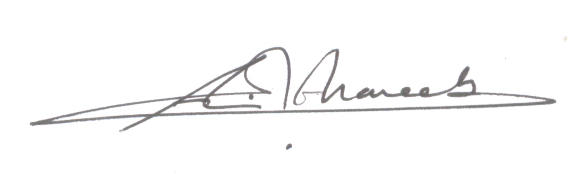
Name of Course Instructor: Abd El-Nasser Ghareeb Abd El-Rahman

Signature: A. Ghareeb Date Report Completed:

Program Coordinator: ___________________________________________________________

Signature: ______________________________ Date Received: _________________________

