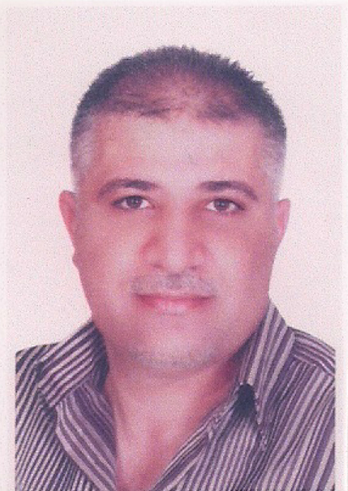
Curriculum Vitae

Name: Emad Mousa Mustafa Alhami
Nationality: Jordanian
Place & Date of Birth: Amman, 25/12/1969
Marital Status: Married
Religion: Islam
Contact: (Tel.:00962788877004; 00966598818583)

Mailing Address: e.alhami@mu.edu.sa
emad.alhami@yahoo.com
Qualifications:
Degree | Major Specialism | University | Graduated Year | Merit
Ph.D. | Condensed Matter & Solid state Physics (Quantum Crystals) | University of Jordan | 2013 | Excellent
M.Sc. | Physics of materials | University of Jordan | 1998 | Very Good
Bc. | Physics | University of Jordan | 1993 | Good

Experience:

Work | Place | Period (s)
Assistant Prof. | Almajmaah university, KSA | 20/8/2014 – Now
lecturer (part time) | University of Hashemite, Zarqa, Jordan. | 1/9/2011 – 10/5/2014
lecturer (part time) | University of Jordan, Amman, Jordan | (3/9/2011–15/6/2012) & (3/9/2008 – 20/2/2009) & (3/9/1995 – 12/1/1998)
Teacher of Physics | Ministry of Education, Jordan | 3/9/1994 – 25/6/2000

Languages & Others:
- Arabic
- English (Toefl)
- Computer (ICDL)

Definite Persons:

- Dr. Humam Ghassib, Prof. / 0777872122 / 0777387870
- Dr. Jamil Khalifah, Prof. / 0777423914
- Dr. Layla Abu Hassan, Prof. / 0795999700
- Dr. Mrouf Haj-Abdallah, Prof. / 0777421334

Publications:
a) Published papers
- In June 2015, ISI Journal with an impact factor (Acta Physica Polonica A; No. 6; Vol. 127, (2015))
“A Microscopic Study of One-Dimensional Solid Helium Using the Static Fluctuation Approximation”
Authors:
1) E. M. Alhami
2) M. K. Al-Sugheir
3) H. B. Ghassib

b) Work under process
[1] “Thermodynamic Properties of One-Dimensional Solid Argon Using SFA”
Author:
E. M. Alhami

[2] “The Electrical Resistance and Magneto Resistance of Ni/Cr/Mn Multi Layers”
Author:
E. M. Alhami

