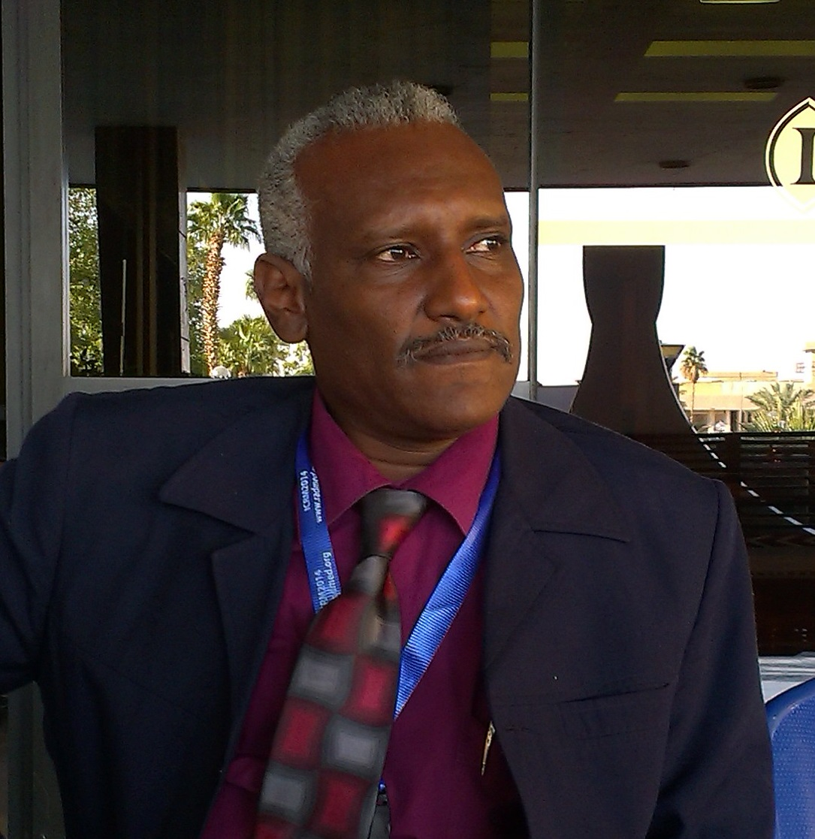
Dr. Nagi Ibrahim Ali Ibrahim
Associate Professor of Nuclear Medicine
Almajmaah university,Riyadh,KSA
College of Applied Medical Sciences
Po.Box.66
Mobile:00966501427432
ni.ali@mu.edu.sa

Qualifications:

Sudanese higher secondary school, 1981
B.Sc. in nuclear medicine (isotope Laboratory) Budapest paramedical School, Hungary, 1986
IAEA Fellowship in nuclear medicine, WHO CCR,Hammersmith hospital, London, UK, 1996
B.Sc. Honor 2nd class division one in nuclear medicine technology, university of Sudan(SUST), 1999
M.Sc. in nuclear medicine technology university of Sudan., 2001
PhD in nuclear medicine technology, Sudan Academy of Sciences (SAS)., 2009

Work Experience:

Sudan Atomic Energy Commission RIA laboratory. 1987 till now.
IAEA training course in bulk reagents methodology for Radioimmunoassay, thyroid related hormone, Tunis, 1992
IAEA training course, preparation of basic reagents for the RIA of Thyroid related hormones .Morocco ., 1993
Regional (AFRA) training course on production of basic reagents for RIA of tumor markers. Tunis.2000.
Head department of central and satellite laboratories. Sudan atomic energy commission.
(SAEC)2001 till now.
Director,Nuclear Application in Biological Sciences (NABSI) Sudan Atomic Energy Commission.2013-2014
Assocaiate professor ,Almajmaah university, college of applied medical sciences,radiological sciences and medical image department. Riaydh ,KSA.2015-till now .

TEACHING EXPERIENCE:-

RIA and related techniques. Sudan Atomic Energy Commission, Khartoum Sudan., Nov 1997
National training course on data processing and quality control in RIA Department of chemistry and radioisotopes (SAEC) Khartoum., April 2002
Basic principle of RIA and related techniques. Sudan Atomic Energy Commission Khartoum Sudan., 2001
Teaching Nuclear Medicine course for postgraduate students, Al-Neelain university. 2001- 2008
Assistant prof.sudan university of science and technology SUST(2010-2013).
Associate prof. sudan university of science and technology SUST(2013- march.2015).
Associate prof.Almajmaah university ,college of applied medical sciences,radiology deparment (since mar.2015).

Supervision:

Master (MSc) projects:
1) Zinc and Copper Levels on diabetic patients in Khartoum. Sudan Academy of science (SAS) 2012 council of biotechnology and environmental sciences.

2) Thyroid status on full term low birth weight deliveries in Sudan (2012) Sudan Academy of science (SAS) council of biotechnology and environmental sciences.
3) Comparative study of thyroid hormonal function between Central and western Sudan(SAS)
4) Essential Trace elements level in Moringa Olivera leaves.(SAS).
5) Hormnal activity on breast cancer menupouse Sudanese women.Alneelain University.
6) Insulin level on young Drug users ( study on Bango users).
7) Trace elements concentration on breast and prostate cancer patients.
External examiner of Master degree to the Nuclear Medicine Technology and medical phisics MSc student. Sudan University of Science and Technology(SUST), faculty of radiological science (2008- 2015)
External examiner of PhD .degree,SUST since 2014

PUBLICATIONS:-
International Journals:
1/ Ibrahim EA, Kheir MM, Elhardello OA, Almahi WA, Ali .N.I, Elbashir MI, Ishag Adam. Cortisol and uncomplicated plasmodium falciparum malaria in an area of unstable malaria transmission in eastern Sudan. Asian Pacific Journal of tropical medicine. Jan (2011).
2/ Adam I, B.Y.Nour, W.A.Almahi, E.S.M.Omer, N.I.Ali. Malaria Susceptibility and cortisol levels in pregnant women of eastern Sudan. International Journal of Gynecology and obstetrics.2007.98:260-1.
3/ Ammar Mohammed Elamin, Rukhsana Ahsan, Nagi Ibrahim Ali, Amal Mahmoud Saeed. Serum prolactin level in healthy Sudanese Subject. Sudan Medical Journal (2008).
4/ Ishraga I.Abdelrahim, Gamal K.Adam, Ahmed A.Mohammed, Magdi M.Salih, Naji I.Ali , Mustafa I.Elbashir, Ishag Adam. Anaemia, folate and vitamine B12 deficiency among pregnant women in an area of unstable malaria transmission in eastern Sudan. Transaction of the royal society of tropical medicine and hygiene. (2009)103:493-496.
5/ E.Y.Ali, G.K.Adam, S.Ahmed, N.I.Ali, I.Adam. Maternal and neonatal hormonal profiles in anaemic pregnant women of eastern Sudan. International Journal of Gynecology and obstetrics. May2009; 29(4):311-314.
6/ Mohamed Bshara, Elhassan M. Elhassan, Naji .I. Ali, Elfatih Osman, Khalid H. Bakheit and Ishag Adam (2009). Anaemia,Zinc and Copper Deficiencies Among pregnant Women in Central Sudan. Biol trace elem Res, Dec2009.
7/ Abdelrahim II,Mahgoub HM, Mohamed AA, Ali. N.I , Elbashier MI, Adam I. Anaemia, folate, Zinc and copper deficiencies among adolescent schoolgirls in eastern Sudan. Biol trace elem Res (2009) 132:60-66.
8/ Ayoub A.Mohamed, Abdelazim A.Ali, Naji .I.Ali, Elshafaee H.Abusalama, Mustafa I.Elbashir, Ishag Adam. Zinc, parity, infection, and severe anemia among pregnant women in kassala, Eastern Sudan. Biol trace elem Res (2010).
9/ Alfarazdeg A. Saad, Omar E.Mohamed,AbdelAziem A.Ali,Ahmed M.Bashir,Naji .I. Ali MustafaI. Elbashir,Ishag Adam. Acute –phase protein in pregnant Sudanese women with severe plasmodium falciparum malaria. Transaction of the royal society of tropical medicine and hygiene 106(2012)570-572.
10/ MOHAMED YOUSEF, ABDELMONEIM SULEIMAN, NAG1.I.ALI, A/M.HASSAN and KHALID.H. ELTOM .CHARACTERIZATION OF RADIOIMMUNOASSAY AND SCINTIGRAPHY AS DIAGNOSTIC TOOLS FOR GOITER IN SUDANESE PATIENTS.Ozean Journal of Applied Sciences 5(2), 2012 ISSN 1943-2429© 2012 Ozean Publication.
11. Alfarazdeg A. Saad, Yassir.A. Doka,Shamselfalah M.Osman,Mamoun Magzoub,Naji I.Ali and Ishag Adam. Zinc, Copper and C - reactive protein in Children with Severe plasmodium falciparum Malaria in an Area of Unstable Malaria Transmission in Eastern Sudan. Journal of tropical pediatrics (2012).
12. Alaeldin Elhadi ¹, Duria A Rayis ¹, Hala Abdullahi ¹, Leana M. Elbashir ¹,Naji I. Ali ² Ishag Adam¹* Maternal and umbilical cord blood levels of zinc and copper in active labor versus elective cesarean delivery at Khartoum Hospital, Sudan.( Biological Trace Element Research ISSN 0163-4984 Biol Trace Elem Res DOI 10.1007/s12011-015-0411) june 2015.
Books:
1) Nagi Ibrahim Ali. A novel Role of Nuclear Medicine Invitro Technology in Pregnancy. (Related Disorders on Sudanese Women).copyright© 2011. Publisher. LAP LAMBERT Academic Publishing GmbH&Co.KG, Dudweiler LanstraBe99,
D-66123Saarbrucken.Amazon Distribution GmbH, Leibzig, Germany.
ISBN: 978-3-8454-1749-3.
2) Nagi Ibrahim Ali and Rihab Mohamed Elamin. Essential bio-indicaters of low birth weight deliveries in Sudan. Publisher. LAP LAMBERT Academic Publishing GmbH&Co.KG., Leibzig, Germany.ISBN-978-3-659-34544-9. Project number:79315 copyright© 2013. Amazon Distribution GmbH.

International Conferences publication:
13/ O.M.ABDALLA, N.E.MUSA, N.I.ALI. Raising of antisera and development of IRMA serum ferritin.IAEA, International Symposium on Modern Trends in Radiopharmaceutical for Diagnosis and Therapy. Lisbon, 30 March – 3 April 1998.
14/ N.I.ALI, M.S.MOHAMMED, O.M.ABDALLA, A.M.ELAIN. Determination of the Normal Range of Thyroid Hormones in Sudanese by Locally Produced Reagent. 5th Arab Conference on the peaceful uses of Atomic Energy, Beirut, 13-7 Nov 2000.
15/ O.M.ABDALLA, A.M.HASSAN, M.M.KHALED, N.M.SHABOO, N.I.ALI. Study on the carcinoembryonic antigen (CEA) and alph fetoprotein (AFP) in serum of toombak users and smokers in Sudan using immunoradiometricassay. 6th Arab conference of peaceful uses of atomic energy Cairo Dec 2002.
16/ N.I.ALI, M.S.MOHAMMED, O.M.ABDALLA, M.A.H.ELTAYEB, A.M.ELAMIN, A.SH.KHALED. Production of donkey anti sheep sera and its uses in RIA, Reunion (2001). 2end congress of the African association of nuclear medicine.
17/ N.I.ALI, M.S.MOHAMMED. Alfa feto protein in liver cancer and liver affecting tropical diseases. South African association of nuclear medicine, Durban, South Africa (1997).
18/ A.M.HASSAN, S.O.BASHIER, M.A.ALTOM, F.A.KHANGI, and N.I.ALI. Iodine versus thyroxin in treatment of simple goiter in Omdurman, Sudan. 6th Arab conference of peaceful uses of atomic energy Cairo Dec (2002).
19/ M.S.MOHAMMED, N.I.ALI. Seminal plazma fractose and Zinc levels as indicator of androgenic activity .1st Arab conference of chemistry, Jordan 2001.
20/ A.M.ELAMIN, A.M.SAEED, R.AHSAN, N.I.ALI. Determination of serum prolactin level in normal Sudanese subjects using RIA kit with locally produced secondary antibody. 2nd international conference of chemistry and its applications Qatar Doha Dec 2003.
21/ N.I.ALI, M.S.MOHAMMED. O.M.ABDALLA, M.A.H.ELTAEB, M.M.OSMAN, A.M.ELAMIN.Use of radioimmunoassay (RIA) to evaluate locally produced secondary Antibodies as a seperation system for some invitro investigations in nuclear medicine .6th Arab conference of peaceful uses of atomic energy Cairo, Dec 2002.
22/ N.I.ALI, O.M.Abdala,M,M Khalid A.M.Hassan, H.A.Hadi,W.A.Almahi. HCG and AFP in Sudanese pregnant women.7th Arab conference of peaceful uses of atomic energy, Sanaa, Yemen, Dec 2004.
23/ N.I.ALI, A.M. ELAMIN, S.H.ABBAS. Development and evaluation of magnetic solid phase radioimmunoassay for total human thyroxin (T4). 9th Arab conference of peaceful uses of atomic energy Lebanon, Beirut. Dec 2008.
24/ N.I.Ali, F.S.Mohamed, M.M.Bushra. Endocrinal investigations on Sudanese malnurished children (2nd International confrence of chemistry and its application, Qatar, Doha 2003).
25/ Omer M.Adallah,Nabila M. Elbagir, and Nagi .I.Ali Preparation of ferritin immunogen and raising of antiserum for immunoradiometric assay,(2nd international confrence of chemistry and its applications,QatarDoha dec 2003).
26/ S.M.Bafarag, M.A.H.Eltyeb, A.M.Elamin, A.M.Hassan, and N.I.Ali. Astudy on the response of breast cancer to adjuvant and radiotherapy using carbohydrate antigen (CA15-3), (2nd international conference of chemistry and its applications, Qatar Doha Dec 2003).
27/ S.M.Osman, O.M.Abdallah and N.I.Ali. Local production of polycononal anti-luteinizing hormone antisera and its use in radioimmunoassay LH kit, 7th Arab conference of peaceful uses of atomic energy, Sanaa, Yemen, Dec 2004.
28/ N.I.Ali, S.M.I.Bafarg, M.A.H.Eltyeb, W.A.A.Almahi and O.M.Abdelgadir. Statistical study on Reproductive Hormones Disorders of Sudanese subjetcs using immunoradiometric assay, 7th Arab conference of peaceful uses of atomic energy. Yemen2004.
29/ N.I.Ali,I.G.Abdulrahman,O.M.Abdalla, , and I.Adam. Early detection of Down’s syndrome on Sudanese pregnant women. (2012).jurnal of medical sciences, Malysia.
30/ N.I.Ali,A.O.Ali,M.A.Abdalrahman.Thyroid status of low birth weight deliveries.12th Arab conference of peaceful uses of atomic energy, Sharmaelshaikh,Cairo,may.2015.
31/ N.A.Mohamed,M.S.Mohamed,and N.I.Ali. CA72/4 and CA125 in early detection and follow up of ovarian carcinoma in Sudan. 12th Arab conference of peaceful uses of atomic energy, Sharmaelshaikh,Cairo,may.2015.

CURRENT RESERCH ACTIVITIES:-
1/ Quantitive determination of cancer antigen (CA15-3) and (CEA) antigen level in serum to monitor the response of breast cancer to radiotherapy and chemotherapy.
2/ Thyroglobulin production by malignant and benign thyroid tuumors, A radioimmunoassay study.
3/ Serum thyroglobulin for early detection of metastases and recurrences in the follow-up of patients with differentiated thyroid carcinoma in Sudan.
4/ Alph-feto-protein (AFP) and (HCG) in pregnancy and pregnancy-realted disorders in Sudan.
5/ Evaluation of thyroid hormones in pregnant women.
6/ Study of AFP and HCG in pregnancydisorders in Sudanese pregnant women. Case studies.
7/ Researches of low birth deliveries in Sudan.
8/ Studies on Moringa olivera as medicinal plant.

