|  |  |
| --- | --- |
| **Mechanical and Industrial Engineering Department** | **Experimental** |

**Material Engineering (ME 251)**

Experiments Manual

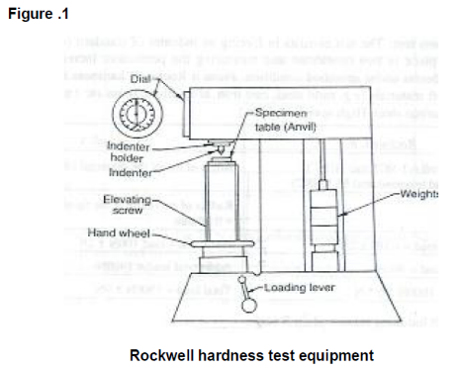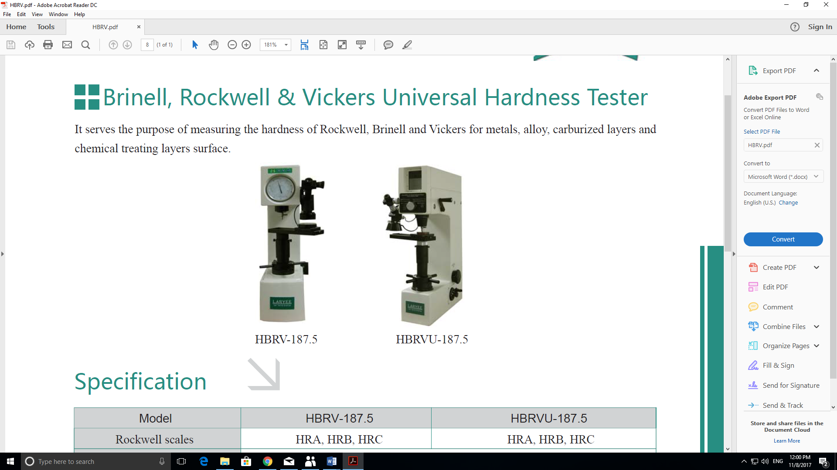

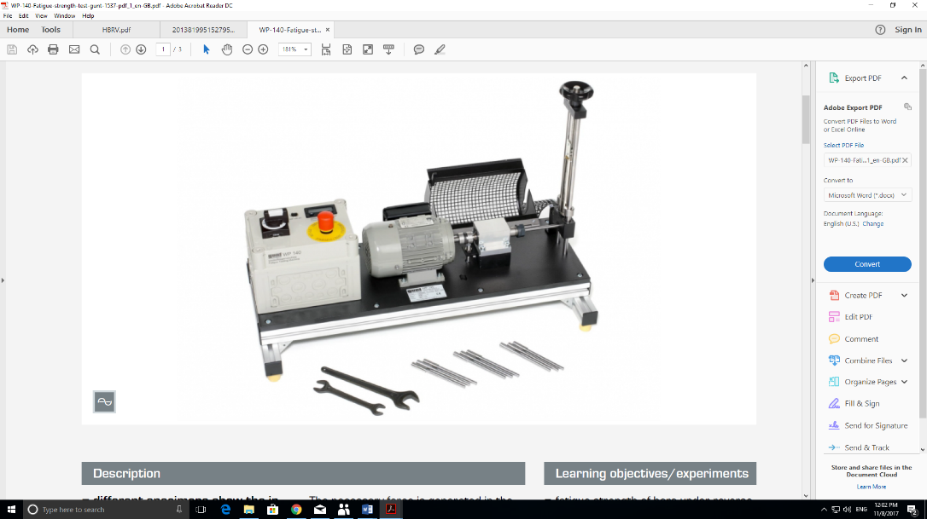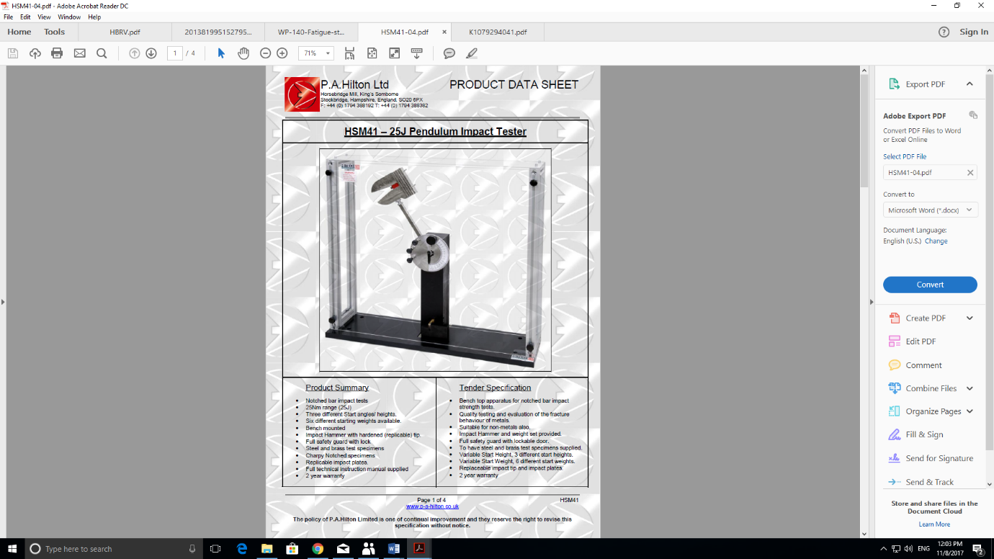

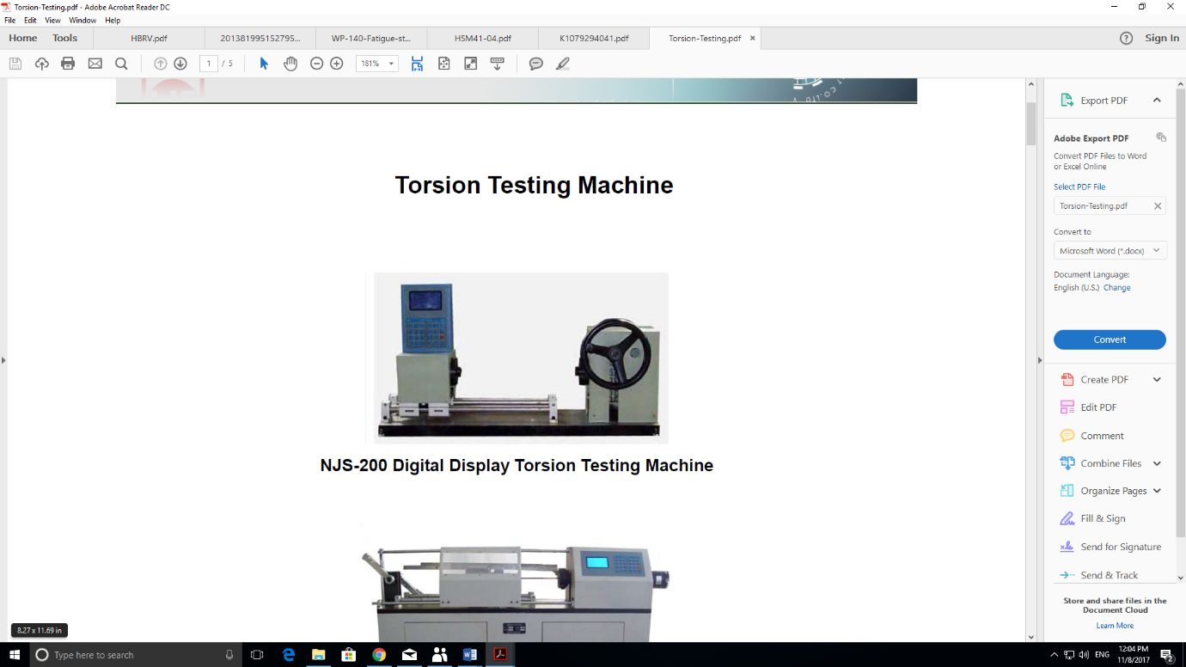

**Updated 2017**

Table of Contents

|  |  |  |  |  |
| --- | --- | --- | --- | --- |
| **No** | **Experiment** | | **Page** | |
|  |  | |  | |
| 1 | Experimental determine the tensile strength of specimen. | | 3 | |
|  |  | |  | |
| 2 | Experimental determine the hardness of the given specimen using Rockwell & Brinell hardness test. | | 12 | |
|  |  | |  | |
| 3 | Experimental determine HSM41 – 25J Pendulum Impact Tester. | | 25 | |
|  |  | |  | |
| 4 | Experimental determine the torsion of specimen. | | 38 | |
|  |  | |  | |
| 5 | Experimental determination fatigue strength test | | 43 | |
|  |  | |  | |
|  | |  | |
|  | |  | |
|  | |  | |
|  | |  | |
|  | |  | |

**Mechanical and Industrial Engineering Department**

|  |  |
| --- | --- |
| Experiment (1) | Universal Testing Machine (Uniaxial Tension Test) |

|  |  |  |
| --- | --- | --- |
| **Student Name** : | **ID:** | **Section No.:** |
| **Supervisor:** Dr. Ibrahim Alarifi | **Submission Date:** | **SLO:** |
| **Academic Year:** 2017-2018 | **Semester:** First |  |

**Object Objective:** To determine the tensile strength of specimen

.

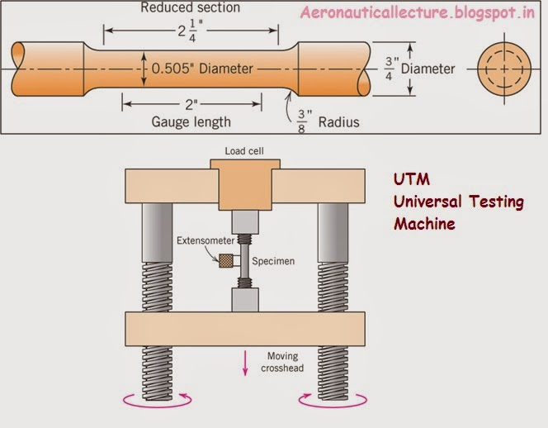

Universal testing machine (Figure 1)

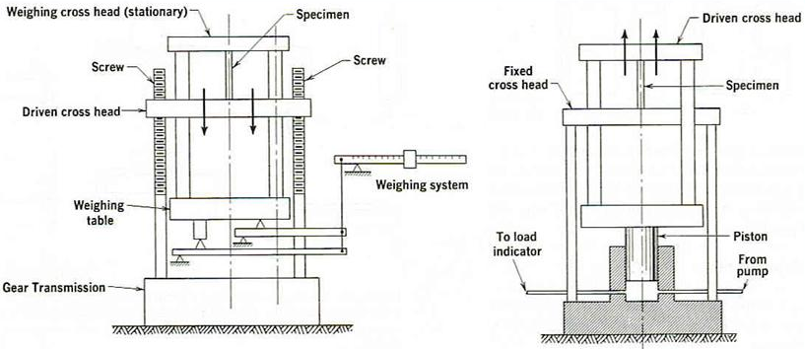

**Figure2**: Universal Testing Machine.

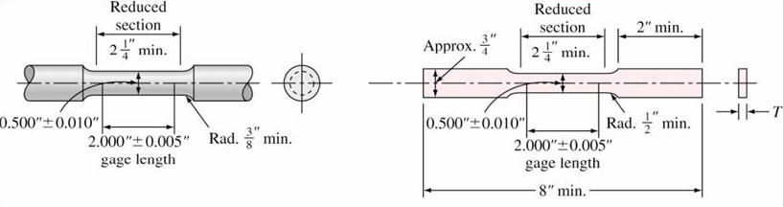

**Figure 3**: Tensile Test Specimen.

**Theory**

When forces are applied to materials, they deform in reaction to those forces. The magnitude of the deformation for a constant force depends on the geometry and internal resistance of the materials. Likewise, the magnitude of the force required to cause a given deformation, depends on the geometry of the material. For these reasons, engineers define stress and strain. Stress (engineering definition) is given by:

$σ= \frac{F}{A}$ (1)

Defined in this manner, the stress can be thought of as a normalized force. Strain (engineering definition) is given by:

$ε= \frac{∆l}{l_{o}}$ (2)

The strain can be thought of as a normalized deformation. While the relationship between the force and deformation depends on the geometry of the material, the relationship between the stress and strain is geometry independent. The relationship between stress and strain is given by a simplified form of Hooke's Law:

$σ=E ε$ (3)

Since E is independent of geometry, it is often thought of as a material constant. However, E is known to depend on both the chemistry, structure, and temperature of a material. Change in any of these characteristics must be known before using a "handbook value" for the elastic modulus.

Hooke's Law (Equation 3) predicts a linear relationship between the strain and the stress and describes the elastic response of a material. In materials where Hook's Law describes the stress-strain relationship, the elastic response is the dominant deformation mechanism. However, many materials exhibit nonlinear behavior at higher levels of stress. This nonlinear behavior occurs when plasticity becomes the dominant deformation mechanism. Metals are known to exhibit both elastic and plastic response regions. The transition from an elastic response to a plastic response occurs at a critical point known as the yield point (σ y). Since a plastic response is characterized by permanent deformation (bending), the yield point is an important characteristic to know. In practice, the yield point is the stress where the stress-strain behavior transforms from a linear relationship to a non-linear relationship. The most commonly used method to experimentally determine the yield point is the 0.2% offset method. In this method, a line is drawn from the point (σ =0,ε =0.2%) parallel to the linear region of the stress-strain graph. The slope of this line is equal to the elastic modulus. The yield point is then determined as the intersection of this line with the experimental data.

In materials that exhibit a large plastic response, the deformation tends to localize. Continued deformation occurs only in this local region, and is known as necking. Necking begins at a critical point known as the ultimate stress ($σ_{utl}$). Since failure occurs soon after necking begins, the ultimate stress is an important characteristic to know. While many experimental tests exist to determine the mechanical properties, the simplest is the tension test. A convenient sample geometry for the tensile test is the "dogbone" geometry (Figure 2). In this test geometry, one end of the test specimen is held fixed while the other end is pulled in uniaxial tension collinear with the long axis of the sample. The forces throughout the sample and test machine are constant, but the stress varies with cross sectional area. The stress reaches critical values first in the region of the sample of minimum cross section, and the minimum cross section is in the sample. Therefore, the properties of the material are determined in this region.

**Experimental Procedure**

A tensile test sample was machined from 1018 steel stock (106.1 mm X 19.05 mm X 3.18 mm) to the geometry shown in Figure 2. The region of minimum cross section had dimensions 6.35 mm in width, 3.18 mm in thickness, and 38.1 mm in length. The error in these dimensions was ± 0.05 mm. This sample was clamped into a Universal Test Machine. One end of the sample was held at a fixed position with the other end was displaced at a constant rate. A load cell was used to determine the force required to maintain a constant displacement rate. The accuracy of the load cell was ± 1 N. Data was collected on a strip chart that monitored the force as a function of chart displacement. The stress in the sample at any force level can be determined from Equation 1. The rate of sample displacement was 1 ± 0.01 mm/min. The elastic modulus, yield point, and ultimate stress were determined from the stress-strain plot.

**Results and Discussion**

The force-chart displacement graph for the 1018 steel examined is shown in Figure 3. The data shown in Figure 3 were converted to a corresponding stress-strain graph (Figure 4). Figure 4 clearly indicates two regions of linear behavior in the low strain region of the stress-strain graph. This behavior suggests that the sample was very compliant at low stress levels, and very stiff at high stress levels. Unfortunately, there is no structural or chemical reason why steel should exhibit an increasing modulus with increasing stress. Therefore, a more probable explanation is realignment and rotation of the test fixture in the low stress (low force) region. Remember, that the text fixture and the sample are under the same applied force. Under these experimental conditions, the most compliant member will dominate the stress-strain behavior. While the fixture appears very compliant during realignment and rotation, the fixture appears very stiff due to its large cross section at higher force levels. In this second region, the stress-strain behavior is dominated by the sample.

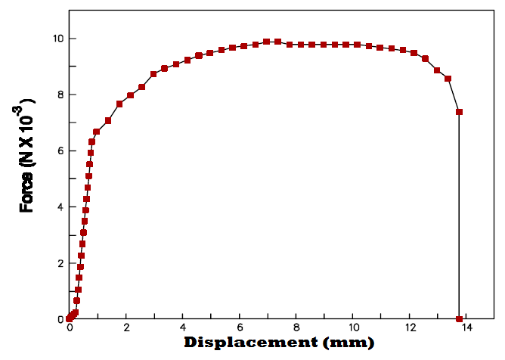

**Figure 3**: Force vs. displacement for 1080 steel tested in tension.

The elastic modulus was determined from the experimental stress-strain data in the second region. This region is shown in Figure 4. The elastic modulus of this steel was determined as 196.7 GPa.

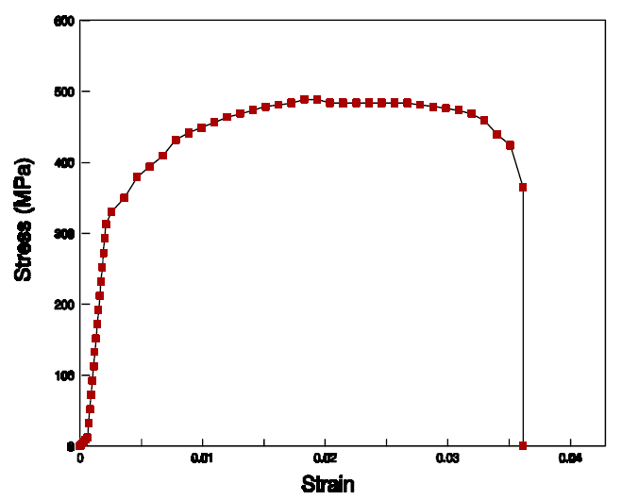

**Figure 4:** Stress-Strain plot for 1018 steel tested in tension.

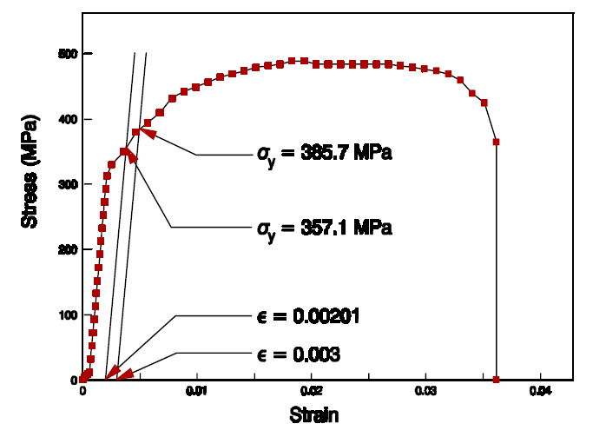

**Figure 5:** Determination of yield point by the 0.2% offset method.

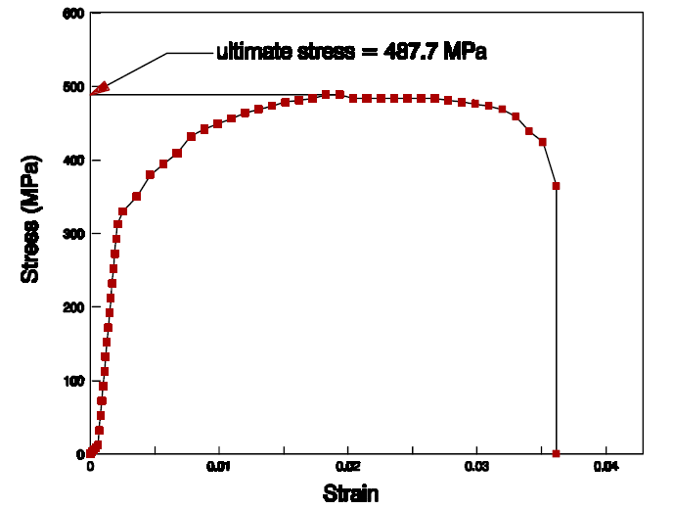

**Figure 6**: Determination of the ultimate strength of 1018 steel tested in tension.

**Conclusions**

The elastic modulus, yield point, and ultimate stress of 1018 steel were determined in uniaxial tension. The "dogbone" specimen geometry was used. The dimension of the region of reduced cross section was: thickness = 3.18 ± 0.05 mm, width = 6.35 ± 0.05 mm, and gage length = 38.1 ± 0.05 mm. At low forces, the dominant response was realignment and rotation of the test fixture. At high forces, deformation of the sample was the dominant response. The elastic modulus, yield point, and ultimate strength values determined are shown in Table I.

**Table 1**: Summary of elastic modulus, yield point, and ultimate tensile strength of 1018 steel tested in uniaxial tension.

|  |  |
| --- | --- |
| Elastic Modulus |  |
| Yield Point |  |
| Ultimate Strength |  |

**Steel**

Table 1 Steel’s true, and submerged masses and density

|  |  |  |  |
| --- | --- | --- | --- |
| MT | MS | (*) |  |
| (g) | (g) | (g/cm3) | (lb/in3) |
|  |  |  |  |

(*)ρH2O = density of water = 1.0 g/cm3

Table 2 Force, Stress, Deformation and strain values for Steel.

|  |  |  |  |
| --- | --- | --- | --- |
| Deformation | Actual Force = gauge force X 1.07 (lbf) | Strain | σ =  (lbf/in2 or Psi) |
|  |  |  |  |
|  |  |  |  |
|  |  |  |  |
|  |  |  |  |
|  |  |  |  |
|  |  |  |  |
|  |  |  |  |



Figure 1 Steel’s Stress Strain Graph



Figure 2 Steel’s Stress-Strain Graph (elastic Stress-Strain Region)

**Brass**

Table 3 Brass’s true, and submerged masses and density

|  |  |  |  |
| --- | --- | --- | --- |
| MT | MS | (*) |  |
| (g) | (g) | (g/cm3) | (lb/in3) |
| 89.10 | 76.80 | 7.240 | 0.261 |

(*)ρH2O = density of water = 1.0 g/cm3

Table 4 Force, Stress, Deformation and strain values for Brass.

|  |  |  |  |
| --- | --- | --- | --- |
| Deformation | Actual Force = gauge force X 1.07 (lbf) | Strain | σ =  (lbf/in2 or Psi) |
|  |  |  |  |
|  |  |  |  |
|  |  |  |  |



Figure 3 Brass’s Stress-Strain Graph



Figure 4 Brass’s Stress-Strain Graph (Elastic Stress-Strain Region)

**Aluminum**

Table 5 Aluminum’s true, and submerged masses and density

|  |  |  |  |
| --- | --- | --- | --- |
| MT | MS | (*) |  |
| (g) | (g) | (g/cm3) | (lb/in3) |
|  |  |  |  |

(*)ρH2O = density of water = 1.0 g/cm3

Table 6 Force, Stress, Deformation and strain values for Aluminum.

|  |  |  |  |
| --- | --- | --- | --- |
| Deformation | Actual Force = gauge force X 1.07 (lbf) | Strain | σ =  (lbf/in2 or Psi) |
|  |  |  |  |
|  |  |  |  |
|  |  |  |  |
|  |  |  |  |



Figure 5 Aluminum’s Stress-Strain Graph



Figure 6 Aluminum’s Stress-Strain Graph (Elastic Stress-Strain Region)

Table 7 Tensile properties for Steel, Brass, and Aluminum

|  |  |  |  |  |
| --- | --- | --- | --- | --- |
| Material Type | Elastic Modulus  ( X106 Psi) | Tensile Strength ( X103 Psi) | Yield Strength  ( X103 Psi) | Ductility  (%El) |
| Steel |  |  |  |  |
| Brass |  |  |  |  |
| Aluminum |  |  |  |  |

**Mechanical and Industrial Engineering Department**

|  |  |
| --- | --- |
| Experiment (2) | Hardness of the given specimen using Rockwell & Brinell hardness test |

|  |  |  |
| --- | --- | --- |
| **Student Name** : | **ID:** | **Section No.:** |
| **Supervisor:** Dr. Ibrahim Alarifi | **Submission Date:** | **SLO:** |
| **Academic Year:** 2017-2018 | **Semester:** First |  |

**Objective:** To determine the hardness the Hardness of a given Specimen using Rockwell hardness test.

**Materials and equipment required:**

Rockwell hardness testing machine.

Black diamond cone indenter,

Hardened steel specimen.

**Theory**

Rockwell test was developed by the Wilson instrument, U.S.A in 1920. This test is used to determine hardness of a material by applying a predetermined force to cause indentation in the specimen. In this test an indenter is forced into the specimen and depth of indentation is measured. The Rockwell scale is a hardness scale based on the indentation hardness of a material. This test is based on IS 1586. Measurement of indentation is made after removing the load. Indenter used is the cone having an angle of 120 degrees made of black diamond.

**Precautions**

1. Thickness of the specimen should not be less than 8 times the depth of indentation in order to avoid the deformation to be extended to the opposite surface of a specimen.

2. Indentation should not be made near the edge of specimen in order to avoid unnecessary stress concentration. As a precautionary measure the distance from the edge of the specimen to the center of indentation should be greater than 2.5 times the diameter of indentation.

3. Load should be applied gently. Rapidly applied load would cause higher indentation and will certainly result in wrong readings. Furthermore, rapidly applied load will restrict plastic deformation and therefore it will disturb the size of indentation.

**Procedure**

1. Examine hardness testing machine (fig.1).

2. Place the specimen on platform of a machine. Using the elevating screw raise the platform and bring the specimen just in contact with the ball. Apply an initial load until the small pointer shows red mark.

3. Release the operating valve to apply additional load. Immediately after the additional load is applied, bring back operating valve to its position.

4. Read the position of the pointer on the C scale, which gives the hardness number.

5. Repeat the procedure five times on the specimen selecting different points for indentation.

**Observation**

1. Take average of five values of indentation for each specimen. Obtain the hardness number from the dial of a machine.

2. Compare Rockwell and Brinell hardness tests results.

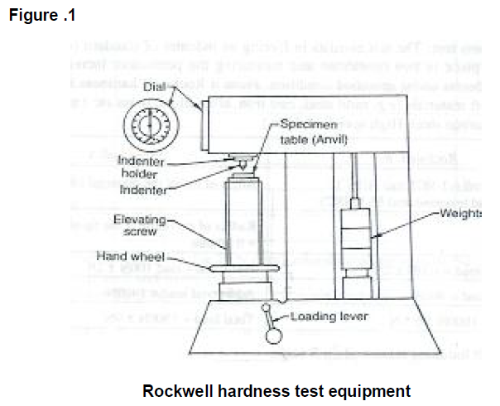

**Result**

Rockwell hardness of a given specimen is determined as ----------- HRC

Table 1 Loads and indenter tips for the three Rockwell hardness values.

|  |  |  |  |
| --- | --- | --- | --- |
| Sample | Scale | Tip | Load  (Kg) |
| Brass | HRB | 1/16” Steel Ball |  |
| Hardened Steel | HRC | Diamond (Brale) |  |
| Gear Tooth | HRN | Diamond (Brale) |  |

Table 2 HRB, HRC, and HRN data values measured.

|  |  |  |  |  |
| --- | --- | --- | --- | --- |
| Trial # | Brass  (HRB) | Hardened Steel  HRC | Gear Tooth | |
| HRN | HRC |
| 1 |  |  |  |  |
| 2 |  |  |  |  |
| 3 |  |  |  |  |
| 4 |  |  |  |  |
| 5 |  |  |  |  |

Table 3 Confidence intervals for the hardness of the tested materials.

|  |  |  |  |
| --- | --- | --- | --- |
| Brass  (HRB)* | Hardened Steel  (HRC)* | Gear Tooth | |
| (HRN)* | (HRC)* |
|  |  |  |  |

* 99% confidence level.

Table 4 Mean values for HRB, HRC, HB, and tensile strength for tested materials.

|  |  |  |  |  |
| --- | --- | --- | --- | --- |
| Material | HRB | HRC | HB | Tensile Strength  (Mpa) |
| Brass |  |  |  |  |
| Hardened Steel |  |  |  |  |
| Gear Tooth |  |  |  |  |

Table 5: Maximum stress versus cable diameter.

|  |  |
| --- | --- |
| Diameter (cm) | Maximum Stress (Mpa) |
|  |  |
|  |  |
|  |  |
|  |  |
|  |  |

Draw Figure of Maximum stress versus cable diameter?

**Problem solution:**

Half of the Tensile strength for the material =

The minimum acceptable diameter of the cable is:

**Appendix 1**

**Calculations for confidence intervals:**

**Brass:**

K = desired percent confidence = 99%

Table 5 Brass HRB sample mean

|  |  |
| --- | --- |
| Trial # | HRB |
| 1 |  |
| 2 |  |
| 3 |  |
| 4 |  |
| 5 |  |
| X = | X = |

S = sample standard deviation = 

Table 6 Brass HRB standard deviation

|  |  |  |
| --- | --- | --- |
| Xi | X | (Xi-X)2 |
|  |  |  |
|  |  |  |
|  |  |  |
|  |  |  |
|  |  |  |
| Σ(Xi-X)2 | |  |

S =  =

Then the confidence interval for the Brass with a 90% level of confidence is:

X – (t α, ν * S / √n) ≤ μ ≤ X + (t α, ν * S / √n)

**Hardened Steel:**

K = desired percent confidence = 99%

Table 7 Hardened Steel HRC sample mean

|  |  |
| --- | --- |
| Trial # | HRC |
| 1 |  |
| 2 |  |
| 3 |  |
| 4 |  |
| 5 |  |
| X = | X = |

S = sample standard deviation = 

Table 8 Hardened Steel HRC standard deviation

|  |  |  |
| --- | --- | --- |
| Xi | X | (Xi-X)2 |
|  |  |  |
|  |  |  |
|  |  |  |
|  |  |  |
|  |  |  |
| Σ(Xi-X)2 | |  |

S =  =

Then the confidence interval for the Hardened Steel with a 90% level of confidence is:

X – (t α, ν * S / √n) ≤ μ ≤ X + (t α, ν * S / √n)

**Gear Tooth:**

Table 9 Gear Tooth HRN, and HRC sample mean

|  |  |  |
| --- | --- | --- |
| Trial # | HRN | HRC |
| 1 |  |  |
| 2 |  |  |
| 3 |  |  |
| 4 |  |  |
| 5 |  |  |
| X = | X = | X = |

S = sample standard deviation = 

Table 10 Gear Tooth HRN standard deviation

|  |  |  |
| --- | --- | --- |
| Xi | X | (Xi-X)2 |
|  |  |  |
|  |  |  |
|  |  |  |
|  |  |  |
|  |  |  |
| Σ(Xi-X)2 | | Σ(Xi-X)2 = |

S =  =

**HRN**

Then the confidence interval for the Gear Tooth with a 90% level of confidence is:

X – (t α, ν * S / √n) ≤ μ ≤ X + (t α, ν * S / √n)

Table 11 Gear Tooth HRC standard deviation

|  |  |  |
| --- | --- | --- |
| Xi | X | (Xi-X)2 |
|  |  |  |
|  |  |  |
|  |  |  |
|  |  |  |
|  |  |  |
| Σ(Xi-X)2 | | Σ(Xi-X)2 = |

S =  =

**HRC**

Then the confidence interval for the Gear Tooth with a 90% level of confidence is:

X – (t α, ν * S / √n) ≤ μ ≤ X + (t α, ν * S / √n)

**Mechanical and Industrial Engineering Department**

|  |  |
| --- | --- |
| Experiment (3) | Experimental determine HSM41 – 25J Pendulum Impact Tester |

|  |  |  |
| --- | --- | --- |
| **Student Name** : | **ID:** | **Section No.:** |
| **Supervisor:** Dr. Ibrahim Alarifi | **Submission Date:** | **SLO:** |
| **Academic Year:** 2017-2018 | **Semester:** First |  |

**Objective:** To determine the impact toughness (strain energy) using Charpy test.

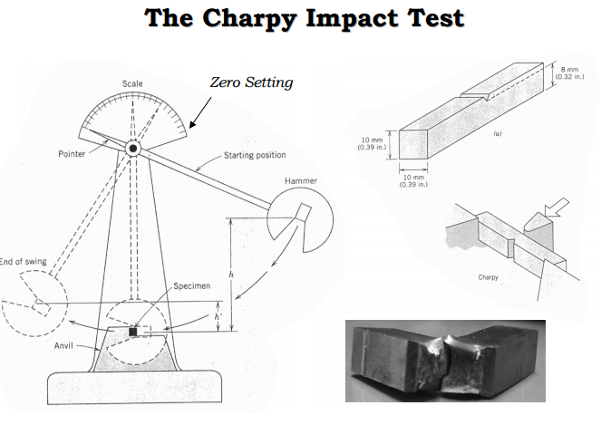

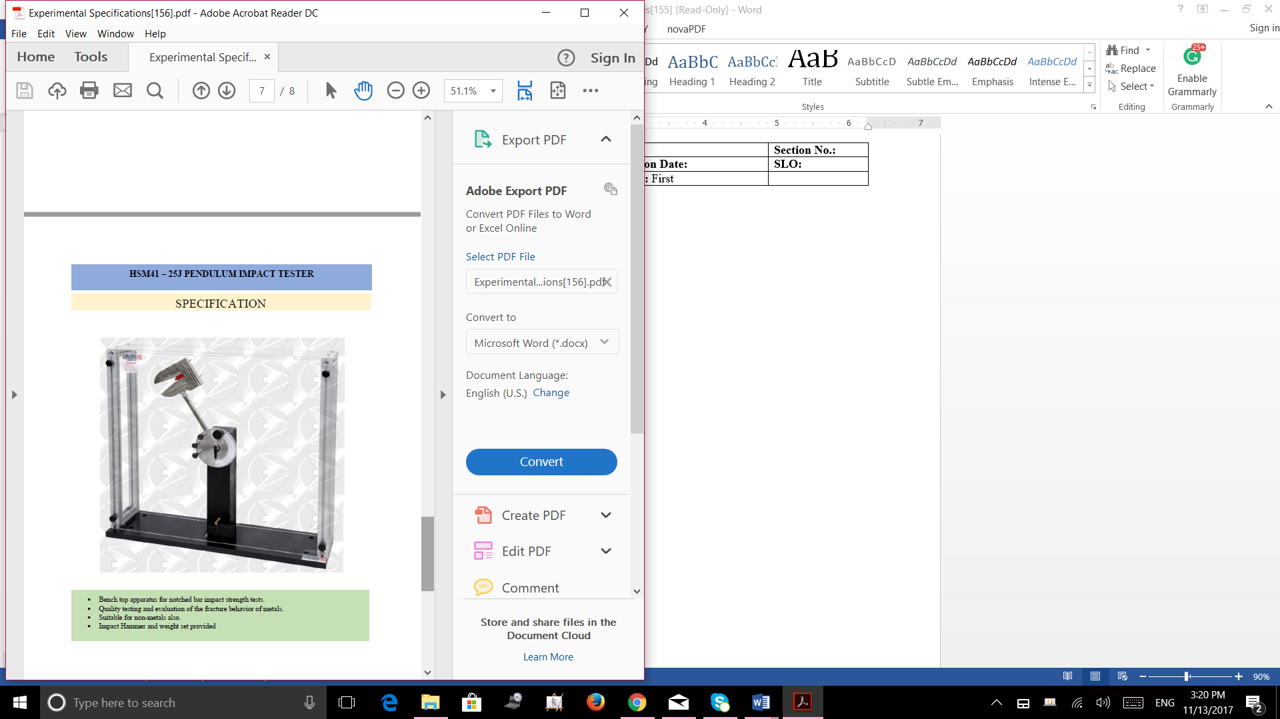

**Impact Toughness using Charpy Test**

Impact tests are designed to measure the resistance to failure of a material to a suddenly applied force such as collision, falling object or instantaneous blow. The test measures the impact energy, or the energy absorbed prior to fracture

**Specimen and specimen**

1. Impact testing machine. (Fig.1)

2. Testing Specimen (Fig. 2)

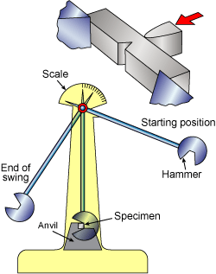

**Figure 1: Charpy Impact testing equipment**

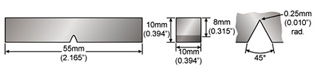

**Figure 2: Testing Specimen**

**Theory**

A metal may be very hard (and therefore very strıng and yet be unsuitable for applications in which it is subjected to sudden loads in service. Materials behave quite differently when they are loaded suddenly than when they are loaded more slowly as in tensile testing. Because of this fact, impact test is considered to be one of the basic mechanical tests (especially for ferrous metals). The term brittle fracture is used to describe rapid propagation of cracks without any excessive plastic deformation at a stress level below the yield stress of the material. Metals that show ductile behavior usually can, under certain circumstances, behave in a brittle fashion. The stress needed to cause yield rises as the temperature falls. At very low temperatures, fracture occurs before yielding. Impact tests are used not also to measure the energy absorbing capacity of the material subjected to sudden loading; but also to determine the transition temperature from ductile to brittle behavior.

Charpy tests show whether a metal can be classified as being either brittle or ductile. This is particularly useful for ferritic steels that show a ductile to brittle transition with decreasing temperature. A brittle metal will absorb a small amount of energy when impact tested, a tough ductile metal absorbs a large amount of energy. The appearance of a fracture surface also gives information about the type of fracture that has occurred; a brittle fracture is bright and crystalline, a ductile fracture is dull and fibrous.

In an impact test a specially designed notched specimen is fractured by a single blow from a heavy hammer and energy require to fracture the specimen is a measure of resistance to impact.

Impact load is produced by a swinging of an impact weight W (hammer) from a height h. Release of the weight from the height h swings the weight through the arc of a circle, which strikes the specimen to fracture at the notch.

In this experiment, polyvinylchloride (PVC) specimen was employed to determine the impact toughness. PVC are excessively used in pipes, rainwater pipelines, electrical insulations,

**Precautions**

1. be careful when releasing the load.

2. Take the accurate readings of dial before and after pendulum strikes the specimen.

3. Repeat the experiments five times and then take the average reading.

**Procedure**

In this test the specimen is positioned across the lowest point in the path of a striker mounted at the end of a pendulum as shown in Figure 1. The striker, having been initially lifted to a specific height h1, and then released, swings against the specimen and breaks it. The striker continues its swing to the other side of the specimen to a height h2. Clearly the difference between the two heights multiplied by the weight of the striker corresponds to the amount of energy that is absorbed in fracture.

Impact Toughness = mg (h1- h2) kJ/m2

**Observations**

Initial and final readings of the dial.

Observe the fractured surface in order to determine whether the fracture is brittle or ductile.

m = 0.5kg

h1 = 0.1 m

h2 = 0.02 m

g = 9.8 m/s2

**Result**

The Impact Toughness of a given specimen (PVC) is determined as ---------------

PVC experiences ductile fracture with a fibrous fractured surface.

**The****IzodTest**

The Izod test has become the standard testing procedure for comparing the impact resistances of plastics. While being the standard for plastics it is also used on other materials. The Izod test is most commonly used to evaluate the relative toughness or impact toughness of materials and as such is often used in quality control applications where it is a fast and economical test. It is used more as a comparative test rather than a definitive test.

**Izod Test Specim****ens**

Izod test specimens vary depending on what kind material is being tested. Metallic samples tend to be square in cross section, while polymeric test specimens are often rectangular, being struck parallel to the long axis of the rectangle. Izod test sample usually have a V-notch cut into it, although specimens with no notch also used on occasion.

**Procedure**

The Izod test involves striking a suitable test piece with a striker, mounted at the end of a pendulum. The test piece is clamped vertically with the notch facing the striker. The striker swings downwards impacting the test piece at the bottom of its swing.

Procedure:

* Information was obtained from the instructor concerning the mass of the pendulum bob and the length of the pendulum arm.
* The sample was mounted in the fixture at the bottom of the arc of the pendulum bob with the notch aligned with, and facing away from, the anvil of the pendulum.
* The pendulum bob was pulled back and was fixed with the magnetic bar, after the apply magnet button on the control panel is pushed.
* The pendulum was elevated to a certain elevation after the crank arm was rotated counterclockwise.
* The release button was pushed and the pendulum was released and was collided with the sample tested.
* The starting and ending angles of the pendulum swing move were read from the control panel in the apparatus.
* The same procedure was done with all samples tested.

Data:

Table 1 Steel’s starting angles, ending angles, friction energies per degree of travel, and the toughness energies.

|  |  |  |  |  |
| --- | --- | --- | --- | --- |
| Trail # | Starting Angle | Ending Angle | Friction energy per degree of travel | Toughness energies |
| Ө1 (deg) | Ө2 (deg) | ΔE/ΔӨ (Joule/deg) | Es (Joule) |
| 1 |  |  |  |  |
| 2 |  |  |  |  |
| 3 |  |  |  |  |
| 4 |  |  |  |  |
| 5 |  |  |  |  |

Table 2 Brass’s starting angles, ending angles, friction energies per degree of travel, and the toughness energies.

|  |  |  |  |  |
| --- | --- | --- | --- | --- |
| Trail # | Starting Angle | Ending Angle | Friction energy per degree of travel | Toughness energies |
| Ө1 (deg) | Ө2 (deg) | ΔE/ΔӨ (Joule/deg) | Es (Joule) |
| 1 |  |  |  |  |
| 2 |  |  |  |  |
| 3 |  |  |  |  |
| 4 |  |  |  |  |
| 5 |  |  |  |  |

Table 3 Aluminum’s starting angles, ending angles, friction energies per degree of travel, and the toughness energies.

|  |  |  |  |  |
| --- | --- | --- | --- | --- |
| Trail # | Starting Angle | Ending Angle | Friction energy per degree of travel | Toughness energies |
| Ө1 (deg) | Ө2 (deg) | ΔE/ΔӨ (Joule/deg) | Es (Joule) |
| 1 |  |  |  |  |
| 2 |  |  |  |  |
| 3 |  |  |  |  |
| 4 |  |  |  |  |
| 5 |  |  |  |  |

Table 4 confidence intervals for the toughness energies of Steel, Brass, and Aluminum

|  |  |
| --- | --- |
| Material | 90 % confidence interval |
| Steel |  |
| Brass |  |
| Aluminum |  |

**Summary of results:**

Appendix **1**

**Confidence intervals calculations for the toughness energies for the tested materials**

**1. Steel**

Table 5 Steel’s sample mean

|  |  |
| --- | --- |
| Trial # | Toughness energies  Es (Joule) |
| 1 |  |
| 2 |  |
| 3 |  |
| 4 |  |
| 5 |  |
| X = | X = |

S = sample standard deviation = 

Table 6 Steel’s standard deviation

|  |  |  |
| --- | --- | --- |
| Xi | X | (Xi-X)2 |
|  |  |  |
|  |  |  |
|  |  |  |
|  |  |  |
|  |  |  |
| Σ(Xi-X)2 | | Σ(Xi-X)2 = |

S =  =

2. Brass

K = desired percent confidence = 90%

Table 7 Brass’s sample mean

|  |  |
| --- | --- |
| Trial # | Toughness energies  Es (Joule) |
| 1 |  |
| 2 |  |
| 3 |  |
| 4 |  |
| 5 |  |
| X = | X = |

S = sample standard deviation = 

Table 8 Brass’s standard deviation

|  |  |  |
| --- | --- | --- |
| Xi | X | (Xi-X)2 |
|  |  |  |
|  |  |  |
|  |  |  |
|  |  |  |
|  |  |  |
| Σ(Xi-X)2 | | Σ(Xi-X)2 = |

S =  =

3. Aluminum

Table 9 Aluminium’s sample mean

|  |  |
| --- | --- |
| Trial # | Toughness energies  Es (Joule) |
| 1 |  |
| 2 |  |
| 3 |  |
| 4 |  |
| 5 |  |
| X = | X = |

S = sample standard deviation = 

Table 10 Aluminium’s standard deviation

|  |  |  |
| --- | --- | --- |
| Xi | X | (Xi-X)2 |
|  |  |  |
|  |  |  |
|  |  |  |
|  |  |  |
|  |  |  |
| Σ(Xi-X)2 | | Σ(Xi-X)2 = |

S =  =

.Appendix 2

**ANOVA calculations**

Table 11 ANOVA calculations

|  |  |  |  |
| --- | --- | --- | --- |
| Trial # | Material | | |
| Steel  Xi  (Es in Joules) | Brass  Xi (Es in Joules) | Aluminum  Xi (Es in Joules) |
| 1 |  |  |  |
| 2 |  |  |  |
| 3 |  |  |  |
| 4 |  |  |  |
| 5 |  |  |  |
| Tc = ΣXi |  |  |  |
| (Tc2/nc) |  |  |  |
| Σ(Tc2/nc) |  | | |
| Ta = ΣXi = ΣTc |  | | |
| Ta2 |  | | |
| Ts = ΣXi2 |  | | |

Appendix 3

**Numerical integration calculations**

**Gray cast iron toughness energy per unit volume**

Gray cast iron toughness energy per unit volume = KPSI

**Polyvinyl chloride toughness energy per unit volume**

Polyvinyl chloride toughness energy per unit volume = KPSI

Polyvinyl chloride has a higher toughness energy value per unit volume than cast iron, and hence, Polyvinyl chloride is tougher than cast iron.

|  |  |
| --- | --- |
| Experiment (4) | Experimental Determine The Torsion Of Specimen |

**Objective**: Determination of shear modulus by torsion experiment

**Devices and Materials:**

- Torsion Sample (Steel and Brass)

- Angle and tork measurement device

- Torsion device

**Required:**

1. Polar moment of inertia of specimen which is known of dimensional properties will be calculated.(Eqn 2)
2. Shear stress and shear strain will be calculated for each torque and torsion angle values. Subsequently these values are written into Table 2 (Eqn5,6)
3. Excel graph will be drawn according to each shear stress and shear strain values. Slope of this graph will be obtained.
4. Slope of Excel graph is equal to shear modulus of material. Calculated shear modulus should be compared with its literature value

**Theory:**

Basic notations of torsion is shown Table 1.

|  |  |  |
| --- | --- | --- |
| Sembol | Tanım | Birim |
| A | Area | m2 |
| M | Moment | Nm |
| F | Load | N |
| L | Total Length | m |
| *l* | Test length | m |
| T | Tork | Nm |
| J | Polar Moment of inertia | m4 |
| G | Shear Modulus | N/m2 |
| D | Diameter of specimen | m |
| r | Radius of specimen | m |
| τ | Shear stress | N/m2 |
| γ | Shear strain | --- |
| θ | Angle of twist | Radyan |

**Shear Modulus**

It is the ratio of shear stress and shear strain of the material.

 (1)

This formula only work when the material is stressed in its elastic region.

**Polar Moment of Inertia**

A higher polar moment of inertia shows that the beam or specimen can resist a higher torsion or twisting force. The diameter of the beam determines polar moment of inertia.

 (2)

**Torque (Torsion Moment)**

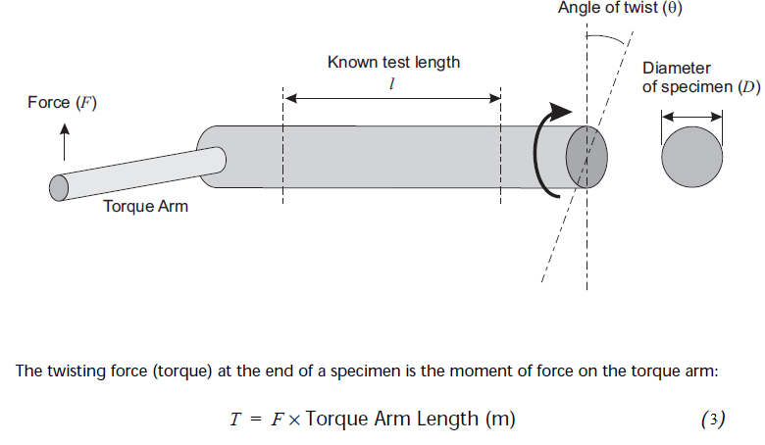

**Figure 1** Torsion

In order to calculate angle of twist;

 (4)

**Shear Stress**

The theoretical shear stress for a solid circular bar is

 (5)

**Shear Strain**

 (6)

Rearrange shear modulus ;

 (7)

**ELASTİK-PLASTİK DEFORMASYON**

This type of deformation is reversible. Once the forces are no longer applied, the object returns to its original shape. Normal metals, ceramics and most crystals show linear elasticity and a smaller elastic range.

This type of deformation is irreversible. However, an object in the plastic deformation range will first have undergone elastic deformation, which is reversible, so the object will return part way to its original shape.

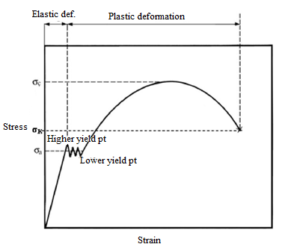

**Figure 2** Stress-Strain curve

Generally material has one yield point under normal circumstances however lower carbon steel as specified mild steel has two yield point as shown figure 2.

1. Discussion:
2. Locate torsion specimen.
3. Firstly angle meter mount on torsion specimen then plastic cap close slowly.
4. During experiments, all torques and corresponding angles are noted.

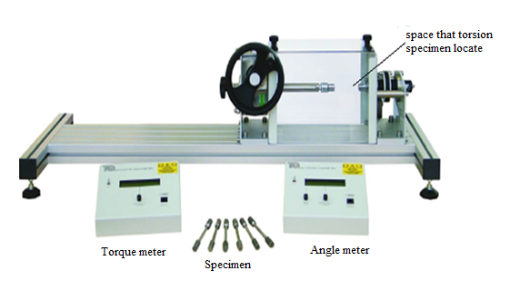**Figure 3 Torsion Test Devices**

1. **Conclusion:**

Table 2 is filled according to values that obtained after the experiments. Shear stress and shear strain values which exist in table are drawn graph by excel then were easily obtained the slope of this graph. Slope of excel graph is equal to shear modulus of material. Finally calculated shear modulus should be compared with its literature value

Table 2 Angle of twist vs. torque, shear stress and shear strain.

|  |  |  |  |
| --- | --- | --- | --- |
| Angle of Twist  (Radyan) | Torque (N.m) | Shear Stress | Shear strain |
|  |  |  |  |
|  |  |  |  |
|  |  |  |  |
|  |  |  |  |
|  |  |  |  |
|  |  |  |  |
|  |  |  |  |

**Mechanical and Industrial Engineering Department**

|  |  |
| --- | --- |
| Experiment (3) | Fatigue Strength Test |

|  |  |  |
| --- | --- | --- |
| **Student Name** : | **ID:** | **Section No.:** |
| **Supervisor:** Dr. Ibrahim Alarifi | **Submission Date:** | **SLO:** |
| **Academic Year:** 2017-2018 | **Semester:** First |  |

**Objective**: To determine the fatigue (endurance) limit for steel using a rotating beam fatigue testing machine. Effects of reversed and repeated cyclic bending.

Note: Since each test must run for hours or days, the data will be collected over the entire semester. During each lab session, a sample will be left running to be removed and recorded during the next lab session.

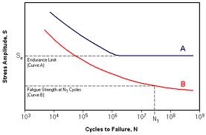**Discussion**:

A steel specimen is subjected to a rotating pure bending stress. It will fail at a stress much lower than ultimate (tensile) strength of material. This failure is due to the repeated cycle of stresses from the maximum to the minimum in bending. By increasing the bending load, failure will occur at fewer bending cycles. On the S-N plot (stress vs cycles to failure) plot A materials exhibit a fatigue (endurance) limit – the stress below which the material will never fail. Plot B materials never reach a fatigue limit so they are given a fatigue strength – the stress for 5x107 cycles (about 20 days at 1820rpm).

**Procedure:**

1. Install the specimen in the machine as per directions.
2. Start the machine then apply the load.
3. Record the start reading on the timer (hr).
4. After the specimen has failed, record the end timer reading.
5. Repeat the above procedure several times at different loads.
6. The machine can run unattended. It will shut itself off upon specimen failure.
7. In a spreadsheet, calculate the stress and cycles to failure for each load. On a semi-log graph, plot the stress vs. cycles to failure and add a power trend line. Determine the fatigue limit and compare the experimental fatigue limit with the estimated fatigue limit. Report the endurance ratio.

Maximum Bending Stress:

T = Tare Weight with no weight on pan (lbs)

L = Moment Arm (in)

d = Diameter of Specimen (in)

W = Weight on Pans (lbs)

RPM = Speed of Motor

$$σ= \frac{Mc}{I}= \frac{M}{S}$$

$$S= \frac{πd^{3}}{32}$$

$$M=\left( \frac{W+T}{2}\right)L$$