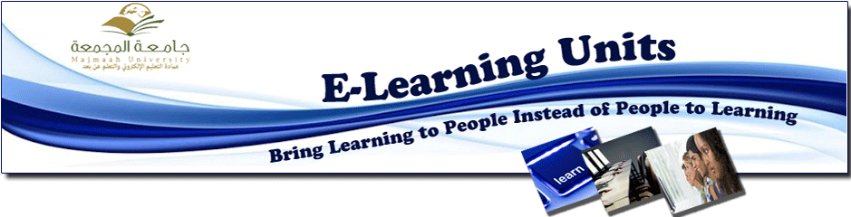
Women E-learning Units Organize Number of Training Activities in the Colleges of the University
Women E-learning Units Organized many training activities within the framework of supporting and enhancing the e-learning activities in the colleges of the university. These activities aimed to develop capabilities and skills of faculty members, it has adressed many topics like: designing e-content using Cuorse Lab software held at Majma'ah colege of education, using sites to design e-content such as (Quick Lessons) and (Lecture Maker) held at Hawtat Sudair college of Science, smart board skills held at Majma'ah colege of education and produced by Mrs. Amal Zahran, designing tests using (Quiz Creator) and (Articulate) held at Majma'ahand Zulfi coleges of education. These training activites were produced by Ms. Moneirah Al-Zouman.

