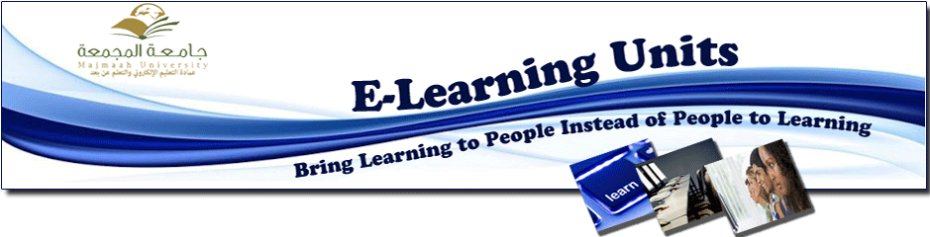
HIS HIGHNESS THE RECTOR RECEIVES THANKS FROM HIS HIGHNESS THE MINISTER OF HIGHER EDUCATION
His Highness the Rector, Dr. Khalid Al-Mogren received thanks from His Highness the Minister of Higher Education Dr. Khalid Al-Angari after viewing the report titled ( 10th Seminar Discussion on E-learning in Newly Established Universities), organized by the university represented by the Deanship of E-learning and Distance Education in cooperation with the National Center for E-learning and Distance Education during the period 24-25/1/1434 H.

