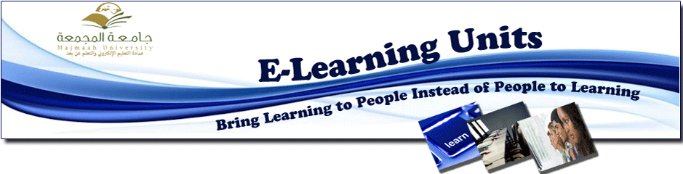
DEANSHIP OF E-LEARNING CONDUCTS TRAINING COURSE FOR DEANS AND VICE-RECTORS
The Deanship of E-Learning and Distance Education completed conducting the course devoted to deans and vice-rectors under the title "A special course of e-learning system for deans and vice-rectors" held by Mr. Faisal Al-Shemmari over the last two days.
The course intended to develop the skills of using e-learning system for faculty members, deans and vice-rectors. This system is regarded as an essential supportive for the educational process due to its multi-functions such as curriculum description and design, homework, exams, educational files management and etc. it is worth mentioning that His Excellency Dr. Musallam Al-Dosari has mentioned that this course was conducted based on the request of faculty members, deans and vice-rectors.

