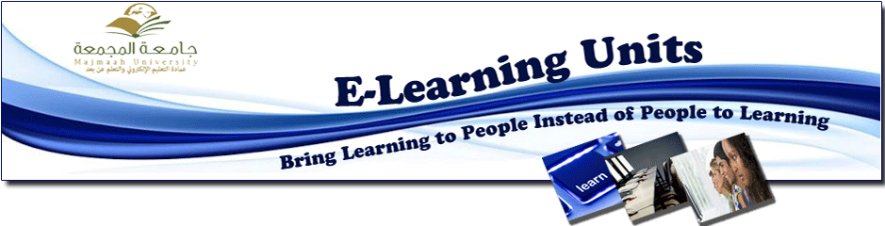

Registration for the training workshops during the forum “Our University is the way to our Potentiality”

The deanship of e-learning organises a number of training workshops during the forum “out university if the way to our potentiality” on the second day of the forum, Tuesday from 9am to 12pm as follows:
Female Workshop:
Entitled (Education work ethics in the virtual community), presented by Doaa’ al-Hazimi from the College of Education at Zulfi, in the training hall.
Male Workshops:
Entitles (Recent developments in e-learning, creating educational application for smart phones), presented by Faisal Hakem al-Shihrie in the university auditorium.
To register, visit the following link and follow the instructions in the available pictures.
http://eservices.mu.edu.sa/user/login

Accepted registrants will be published on 12th Feb 2013.

