Zulfi College of Education establishes a training course entitled "Designing interactive modules using Articulate"
Tuesday 13/6/1434
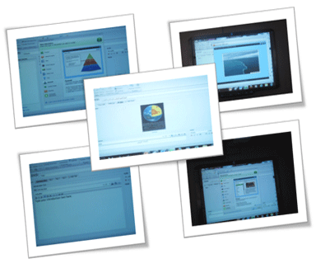
In pursuit of Deanship to develop the skills of faculty members in the field of e-learning in order to produce a better education; Women's training unit organized a training course entitled "Designing interactive modules using Articulate", produced by Ms. Moneirah Al-Zouman in collaboration with the unit of e-learning and distance education in Zulfi College of Education. The training course was attended by faculty members and it aimed to give them the skills of designing, publishing and interactive learning modules for e-learning courses. (ARTICULATE) is software intended to build courses and tests and convert PowerPoint files to interactive files.

