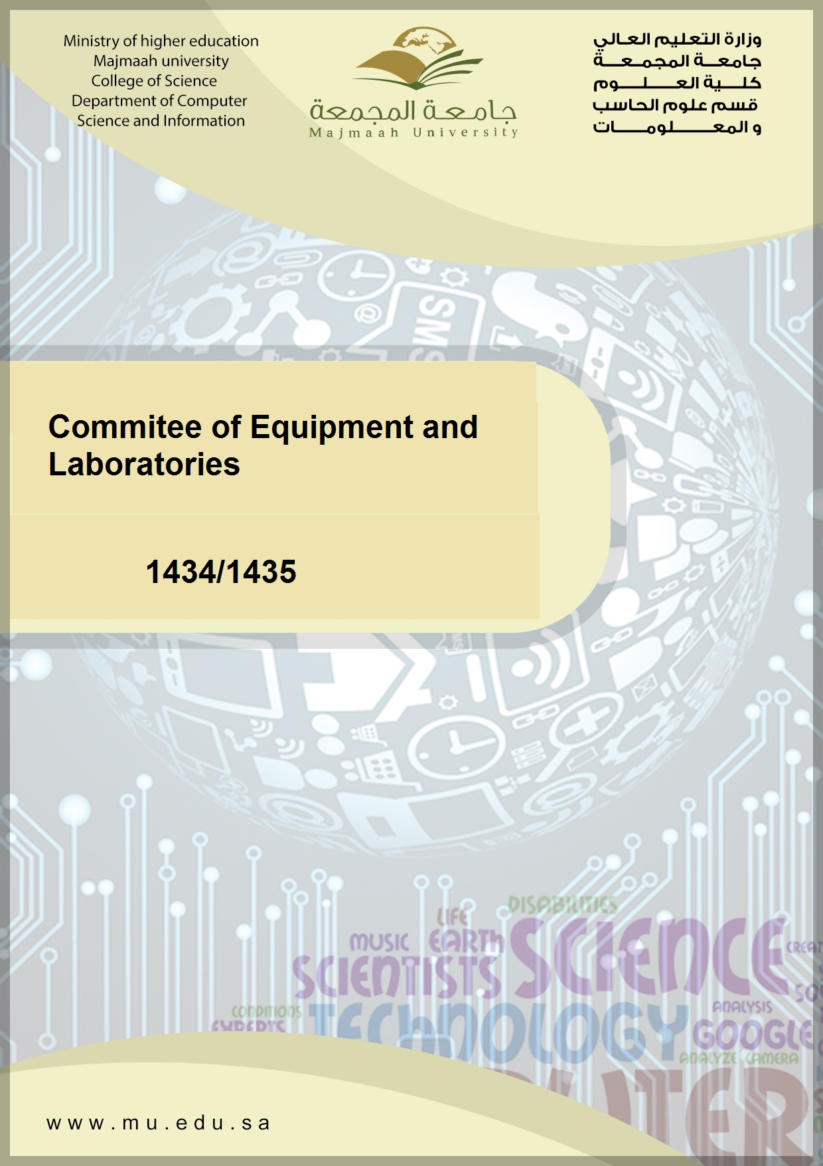

|  |  |  |
| --- | --- | --- |
|  |  |  |

Preparation

Mohammad AL Khaldy

Head of the Commitee



Contents

Introduction 3

Mission , Vision , Objectives 5

Vision 5

Mision 5

Objectives 5

The decision to establish the Commitee 8

Committee members 9

Delegate 10

Meeting 11

Activities and achievements 12

Problems and constraints 15

Recommendations ……..……………………………………………………………….16

Accreditation Handbook 17



# Introduction

# The laboratories and computer equipment considered from the most important means and tools that directly affect the Department of Computer and Information Sciences, and this is what the department called for the establishment of a committee on the laboratories equipment to the manage and follow-up.

# Also, create the best educational services that help provide the scientific material and research in an integrated manner, and pleased, and ease, and smoother, and the level of mastery would be tantamount performance in laboratories and specialized laboratories and workshops.



# Vision, Mission and Goals

**Vision Committee**

See the show through the work to achieve the vision and mission of the university to be in the ranks of universities in the world in all areas of laboratory instruction and by providing the best and latest equipment of laboratories that meet the requirements of the typical Academic Accreditation in coordination with the competent authorities .

**Message Committee**

Access to all laboratories of the University to the highest possible level of advancement and progress , which enables students and researchers to accomplish their tasks laboratory lab easily and conveniently with high quality and in harmony , integration and fun .

**Objectives of the Committee**

     * preparing the laboratories needed for college and hardware specifications and laboratory units .

    * Work on the preparation on labratory in a suit its purpose, and to provide all the requirements .

    * Make sure to match the hardware specifications required for laboratories supplied prior to the completion of the procurement process .

    * Make sure there is regular maintenance of the labratory, and replace the damaged and especially with the end of each semester .

    * preparing laboratory as well as the necessary furniture and teaching aids appropriate .

**Outline of the labs the Department of Computer and Information Sciences**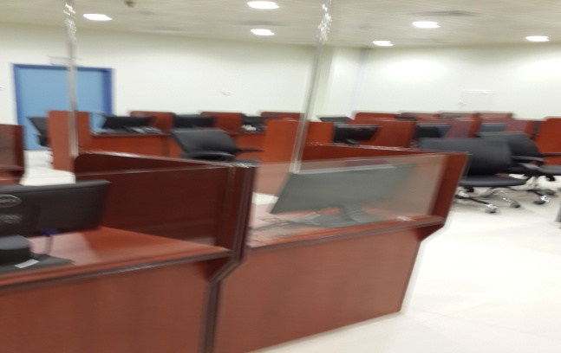

**1-Networks Lab:**

**This lab is equipped with the latest hardware and software developed to cover all aspects of the process with respect to the decisions of the networks, where it was the introduction of 28 new device with high-speed network in addition to all the equipment needed to train students on how to set up and manage networks. It also contains an interview with surfer and dispensers and all the equipment, wired and wireless networks.**

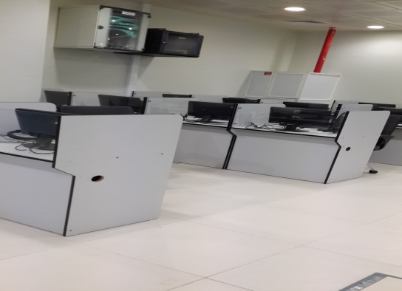

**2- Database Lab:**

**Equipped with 30 computers and database software such as Oracle, SQL Server, and all the software that obliges students to be trained to set up databases and handling, provider network modern connected with surfer to cover all aspects of the operation of the decisions of databases and design interfaces and visual programming and all areas of databases**

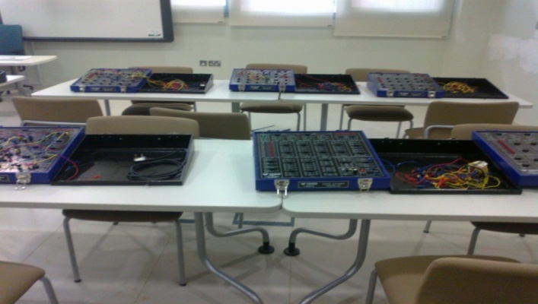

**3-Assemby Lab:**

**Contains 16 units of modern design rationale for the student should be able to understand the working principle of logic circuits and how to build logic gates, and the design of systems logic and microprocessors, and there is a future plan for the development of the plant and provide him with the latest equipment to design logic circuits.**

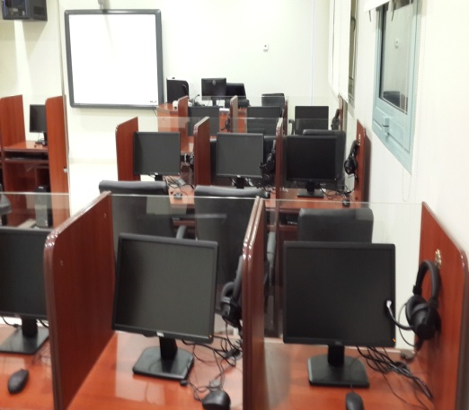

**4-Operating Systems Lab:**

**Contains 30 sophisticated device in addition to the software operating systems such as windows and Linux operating systems and networking necessary to qualify the students to deal with all the operating systems in addition to the existence of a sophisticated network. There is a future plan for the development of this plant to deal with all that is new in the field of operating systems for Giving students the practical skills necessary for the student should be able to deal with all operating systems.**

**5-Digital Design Lab:**

**Is equipped with modern laboratory and a specialized device contains 30 modern and sophisticated software in addition to the operating systems Windows 7 and Office 2010, with modern equipment that helps students acquire basic computer skills.**

**In addition to the presence of a modern network devices and control network for the Acquistion of junior students from all disciplines of basic skills needed to deal with the computer and its applications in practical life.**

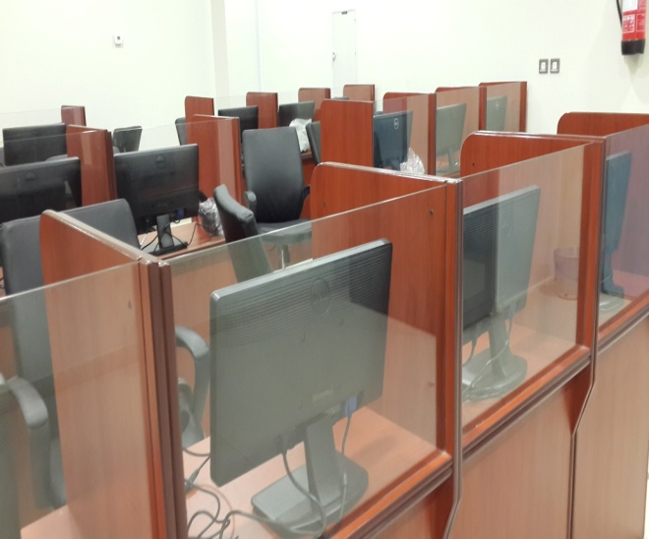

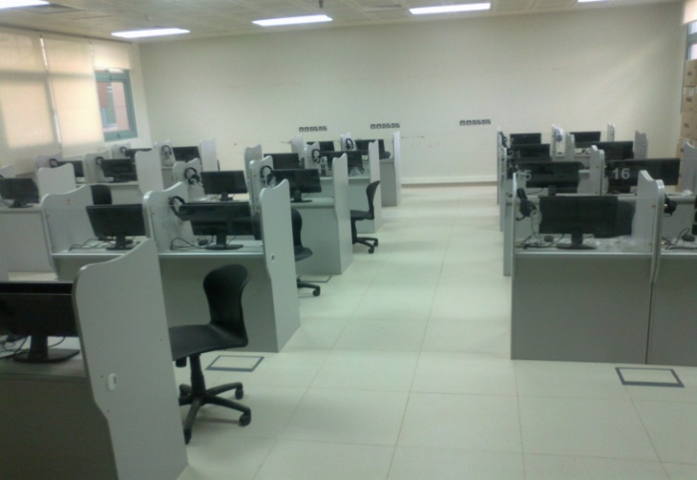

**6- preparatory(1) Lab:**

**Is equipped with modern laboratory and a specialized device contains 28 modern and sophisticated software in addition to the operating systems Windows 7 and Office 2010, with modern equipment that helps students acquire basic computer skills. In addition to the presence of a modern network devices and control network for the Acquistion of junior students from all disciplines of basic skills needed to deal with the computer and its applications in practical life.**

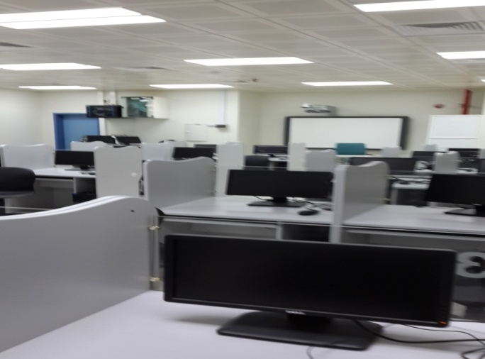

**7- preparatory(2) Lab:**

**Is equipped with modern laboratory and a specialized device contains 28 modern and sophisticated software in addition to the operating systems Windows 7 and Office 2010, with modern equipment that helps students acquire basic computer skills.**

**In addition to the presence of a modern network devices and control network for the Acquistion of junior students from all disciplines of basic skills needed to deal with the computer and its applications in practical life.**



**The decision to establish the Committee**

**Committee was created laboratories and devices based on the decision of the Department of Computer and Information Sciences Department at the meeting No. (1) dated 10/13/1434**

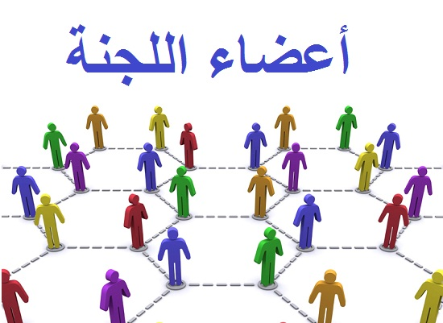

# myyyy 001.jpgcommittee Members

Mohammad AL Khaldy - Head

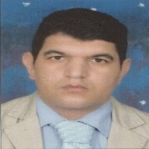Dr. Mohammad Wagieh - Member

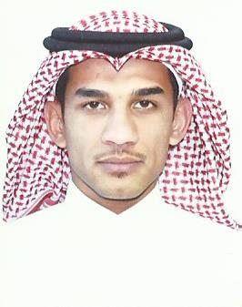

Thamer Almasoud - Member

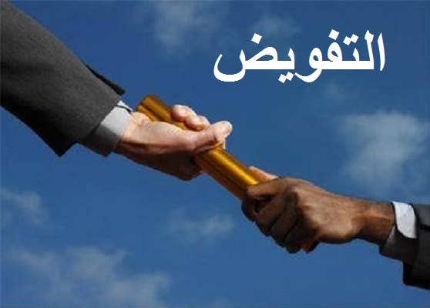

**Delegation**

**Mr. Thamer Al Masoud duties of chairman of the labs and devices in the absence of the Chairman, Mr. Mohammed AL Khaldy.**

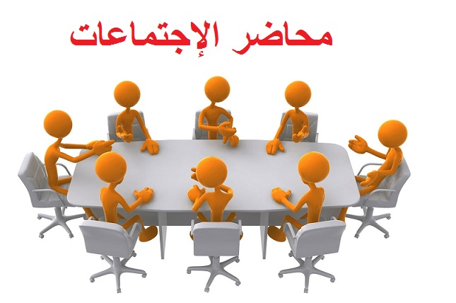

**The Committee shall hold its meetings as any other business, where we held five meetings since the beginning of this year, was mostly to discuss and receipt of new labs.**



**Activities and achievements**

**1 - Follow-up labs and their needs first hand.**

**2 - Follow-up to the needs of teachers and secured.**

**3 - Coordination for a session inside the labs and outside working hours.**

**4 - Received four new labs for the current year.**

**5 - Sessions for faculty members on new technologies with new labs.**

**Training for the new system DBS on 4/1/1435**

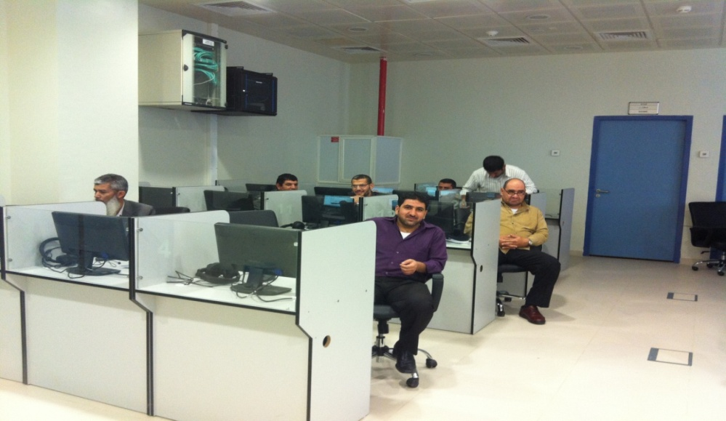

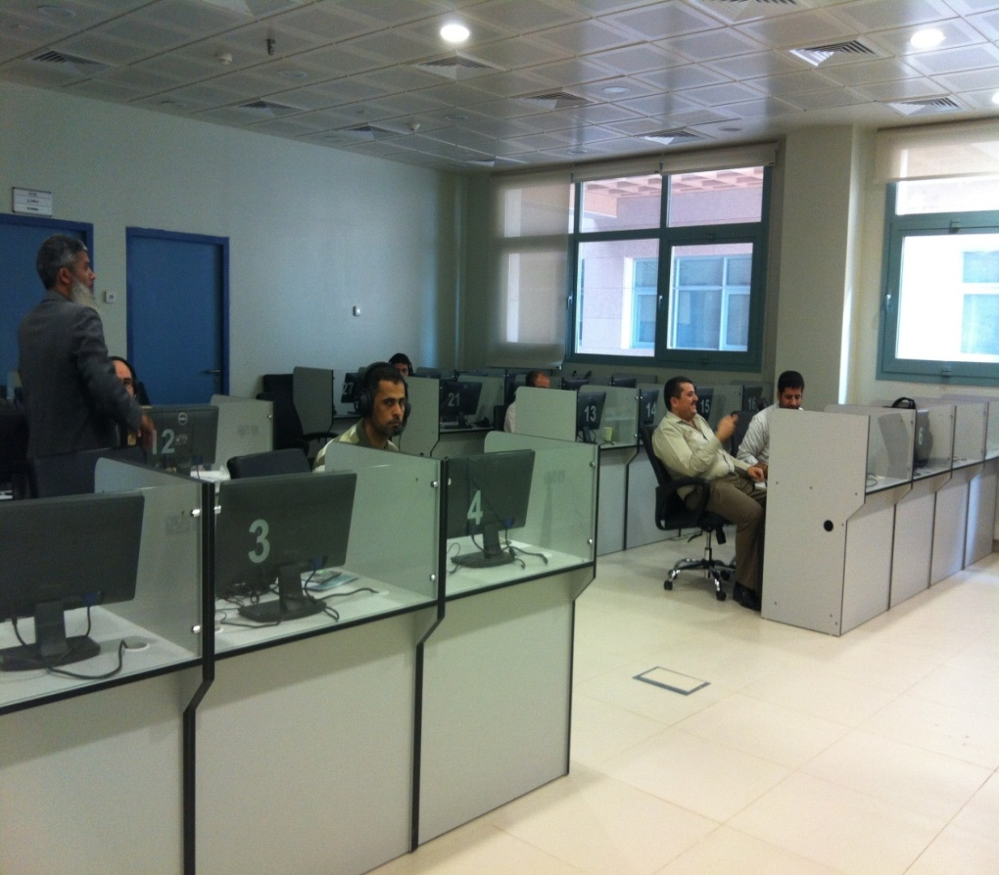

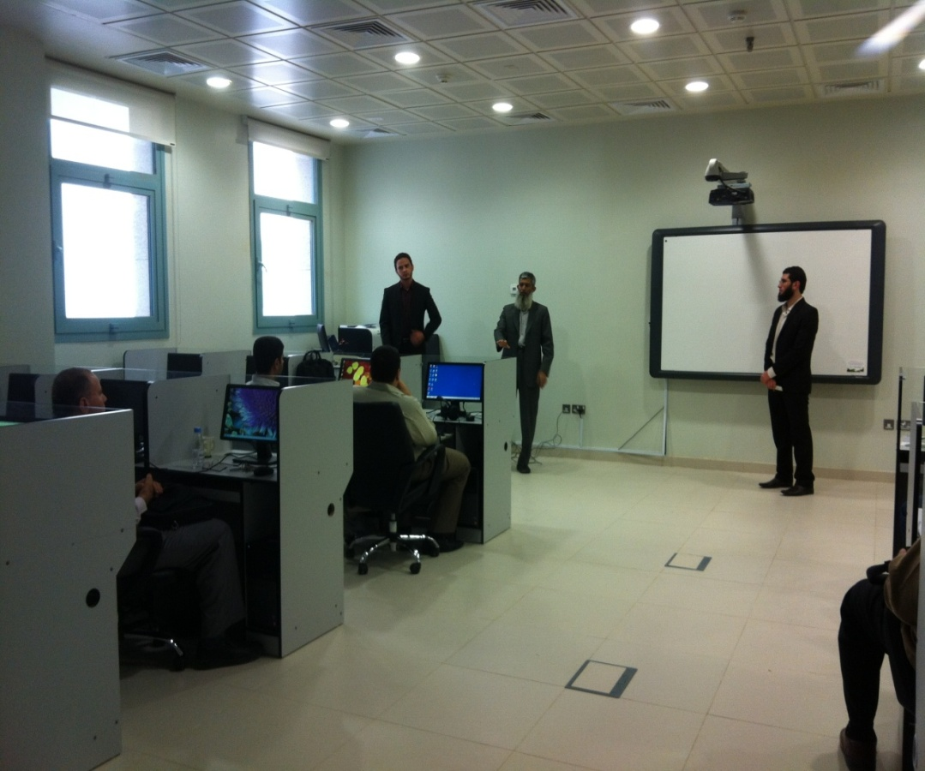

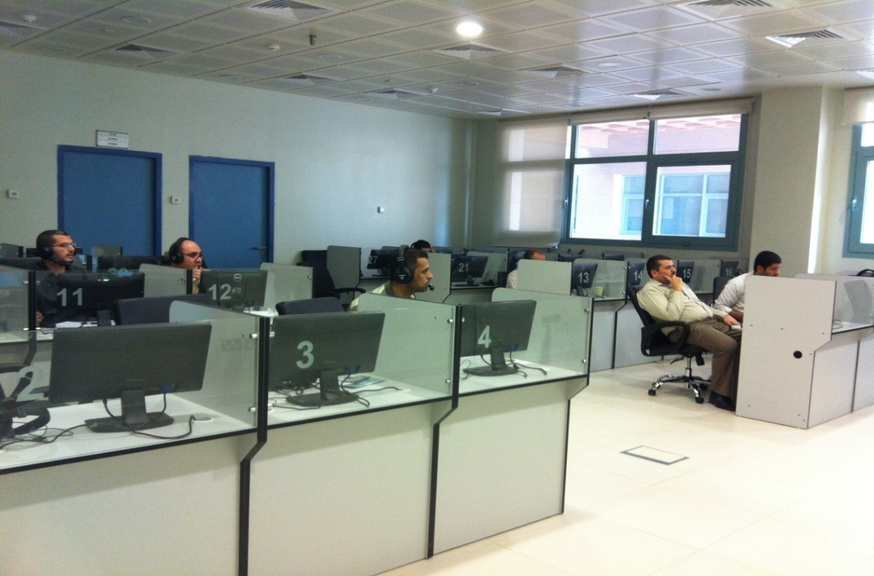



**Problems and constraints**

**The grace of God, and the wisdom of the administration and the Faculty of Science, Majmaah University, there are no problems or constraints to remember, Update laboratories continuously and on an annual basis to provide the students of Department of Computer Science Faculty of the rest of the sections with the latest tools and equipment necessary to cope with the requirements of the digital age. All that is requested from the Dean of the Faculty of Science labs are about the immediate response.**



**Recommendations and Suggestions**

**1 - Committee recommends to the labs your colleagues in the Department of Computer need to alert students to the proper handling of equipment and laboratories located , to keep providing services to other colleagues brothers .**

**2 - The Committee recommends that your colleagues in the Department of Computer need to maintain the labs and their contents are constantly urged students to maintain existing services and laboratories .**

**3 - The Committee recommends that your colleagues in the Department of Computer and other departments , the need to ensure the closure of the equipment in the labs after the end of lectures and courses , and an emphasis on students close the devices at the end of the lecture.**

**4 - The Committee recommends that your colleagues in the Department of Computer , not to hesitate to ask for any help from the Committee on labs and devices.**

**5 - The Committee recommends that your colleagues in the Department of Computer and other departments not to hesitate to ask for any hardware or plants necessary for the department or college to be proposed to the Dean of the College .**



**Accreditation this booklet**